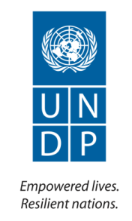
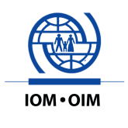
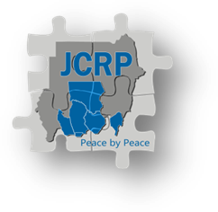

Joint Conflict Reduction Programme (JCRP)

Annual Report - 2013

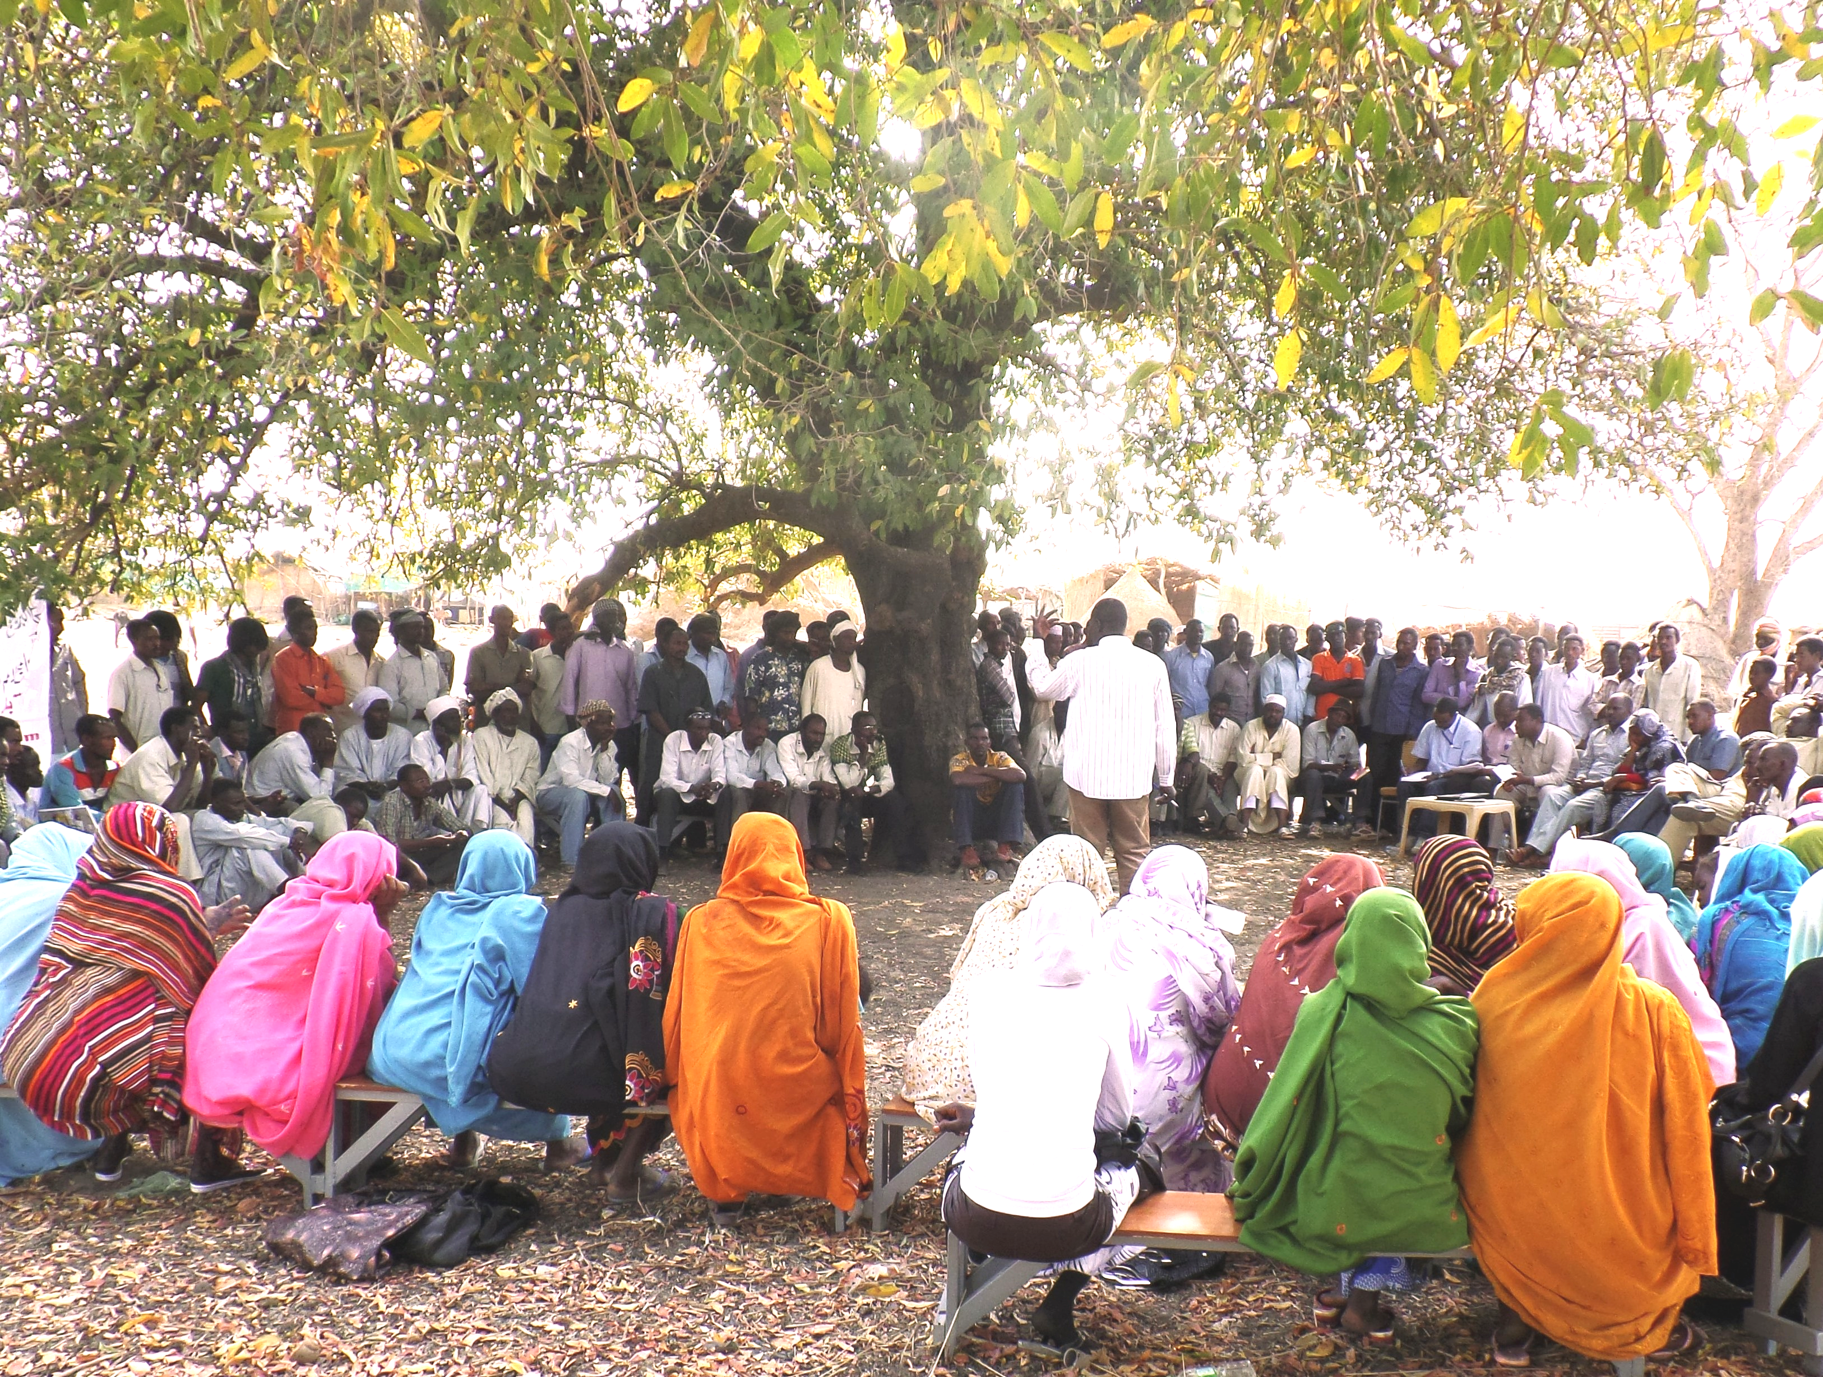
Photo Credits: UNDP

Implementing Agency: | United Nations Development Programme  International Organization for Migration
Country/Region or Area: | Sudan
Project Title and ID: | Joint Conflict Reduction Programme (JCRP)
Project Duration: | January 2012-December 2016
Project Budget (AWP): | USD 3,724,154
Reporting Period: | January – December 2013
Total funds available (US $): | USD 3,724,154 (EU Contribution; 2,299,607, Norway Contribution; 786,258 and TRAC Allocation; 150,000)
Contact Person/s: | Adnan Cheema (adnan.cheema@undp.org)  Program Manager

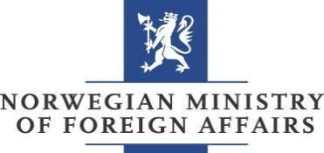
Table of Contents

Acronyms 3
I. Executive Summary 4
II. Introduction 6
III. Progress Review: Key Activities and Results, Jan – Dec 2013 8
IV. Monitoring and Evaluation 22
V. Key Challenges, Lessons Learned and Recommendations 25
VII. Partnerships and Sustainability 33
VIII. Financial Summary 35
Annexes

Acronyms

AA  AWP  BNS  CBO  CS  CPA  CPAP  CRP  CSO  DNH  GC  GoS  HAC  ICT  IDP  INGO  IOM  IP  JCRP  JEM  LoA  M&E  MDG  MI  MoA  MoE  MoF  MoFNE  MoH  NA  NCP  NGO  NISS  PB  PC  PCSPC  PDF  RPCM  SAF  SKS  SPLA  SPLM  SPLM/A-N  TOT  UNDAF  UNDP  UNDSS  UNISFA  UoK  WES | Abyei Area  Annual Work Plan  Blue Nile State  Community Based Organization  Conflict Sensitivity  Comprehensive Peace Agreement  County Programme Action Plan  Conflict Reduction Programme  Community Service Organization  Do No Harm  Grants Committee  Government of Sudan  Humanitarian Aid Commission  Information and Communication Technology  Internally Displace Person  International Non Government Organization  International Organization for Migration  Implementing Partner  Joint Conflict Reduction Programme  Justice and Equality Movement  Letter of Agreement  Monitoring and Evaluation  Millennium Development Goal  Military Intelligence  Ministry of Agriculture  Ministry of Education  Ministry of Finance  Ministry of Finance and National Economy  Ministry of Health  Native Administration  National Congress Party  Non Government Organization  National Intelligence and Security Services  Peace Building  Peace Council  Peaceful Coexistence and Social Peace Committee  Popular Defense Forces  Reconciliation and Peaceful Co-existence Mechanism  Sudan Armed Forces  South Kordofan State  Sudan People’s Liberation Army  Sudan People’s Liberation Movement  Sudan People’s Liberation Movement/Army - North  Training of Trainers  United Nations Development Assistance Framework  United Nations Development Programme  United Nations Department of Safety and Security  United Nations Interim Security Force for Abyei  University of Khartoum  Water, Environment and Sanitation

I. Executive Summary

Introduction

This Annual Report covers the period January – December 2013 for the Joint Conflict Reduction Programme (JCRP) implemented by IOM and UNDP. The report details some of the key contextual developments over the course of the year, the adjustments JCRP made in the face of the challenges these developments posed and the results achieved. Progress against outputs and outcomes, a financial summary and a revised Risk Log are also provided. In addition, an analysis of challenges, lessons learned and recommendations for the way forward are offered, as the programme moves into Phase II.

Operational Context

The year 2013 witnessed a number of important events in the programme areas. Some of the most critical of these include;
- The killing of the Ngok Dinka Paramount Chief in Abyei in May;
- The change in administrative divisions resulting in the reinstatement of West Kordofan;
- The dissolution of the RPCM and its replacement with the newly formed Peaceful Coexistence and Social Peace Committee (PCSPC);
- Ongoing tensions in the Abyei Area due to its ongoing unresolved political status and continued lack of a local administration;
- The hosting of a unilateral referendum by the Ngok Dinka community in the Abyei Area in October, further heightening tensions between Ngok Dinka and Misseriya and Sudan and South Sudan;
- Nationwide inflation and civil unrest in Khartoum in the wake of the lifting of fuel subsidies in October ;
- Intensification of conflict between the Sudanese Armed Forces (SAF) and the Sudan People’s Liberation Army – North (SPLA-N) in Blue Nile State (BNS) and in particular in South Kordofan State (SKS), in the final months of 2013 and;
- The outbreak of armed conflict in neighboring South Sudan in December 2013.
The challenges these events posed for JCRP are explored in more detail in both Section V. and VI. A comprehensive conflict analysis, completed in October, is also provided in Annex II.

Progress against outputs and outcomes

Despite considerable challenges in the operational context, JCRP made significant progress towards CPAP Outcome 7: ‘Government and civil society initiatives that promote social cohesion, peace consolidation and pluralism are strengthened’. Some of the most important results achieved in 2013 include;
- The capacity of the Blue Nile Peace Council is increasing, as evidenced by their growing ability to effectively lead and implement peacebuilding activities, with the need for JCRP support decreasing over time;
- The Peace Council, with support of JCRP was instrumental in establishing 27 local level peace committees along the migratory routes in BNS. These local level institutions are increasingly playing an important role in resolving local level conflicts. With further support and coordination, there is potential for this new network to c0llaborate in the establishment of an early warning system at the community level;
- Conflict has been significantly reduced and livelihoods improved in the Lagawa and Al Sunut areas of West Kordofan State (WKS), providing an excellent example of the gains possible with sustained peacebuilding efforts over time;
- Conflict has been reduced along three migratory routes in Blue Nile State due to the process of corridor demarcation/compensation in tandem with the delivery of peace dividends. The PC advised that the number of disputes between farmers and pastoralists reported to police have dropped from around 400-500 each harvest season to less than 30 in the recent harvest season, as of November;
- JCRP supported two new peace processes, resulting in Agreements in 2013 between the following communities the Misseriya-Rizegat (SKS and East Darfur) and Diree Toroj (WKS). A new agreement between the Saror-Heiban (WKS) was also reached following a break-down in an earlier peace agreement. As of the end of December, 17 out of 18 peace agreements were continuing to hold.
- Misseriya re-opened markets that had been closed for more than a year, as well as water sources along the Western corridor to Rizegat communities in WKS as a result of six community forums, culminating in a one day conference at which diya (blood money) was paid to compensate for loss of lives, with both communities affirming their commitment to the Misseriya-Rizegat Reconciliation Agreement;
- The range and number of community stakeholders committed to peacefully resolving conflict grew as a result of expansion into new areas, training a broader range of community actors and through the highly successful Universal Peace Day in BNS, in which 7500 men, women and children participated and;
- More CSOs are applying Do No Harm and Conflict Sensitivity principles in their work as a result of trainings provided by JCRP, with positive peacebuilding impacts on local communities.

Key Challenges and Risks

Some of the key challenges and risks faced by JCRP in 2013 included; ongoing security and access issues limiting or delaying the implementation of activities, the political sensitivities in undertaking conflict reduction work, the absence of an Administrative structure in Abyei, the difficulties of operating in the absence of Government counterparts, changes in administrative boundaries and Governors and the restrictions on international NGOs work in West Kordofan and Blue Nile State. Some of the key mitigation measures adopted by JCRP in 2013 included; expanding the range of partners to enable work to continue in areas without a Government counterpart and to address neutrality concerns; ensuring staff safety through adherence with UNDSS security protocol and the deployment of an international peacebuilding specialist to Abyei upon the evacuation of national staff from the area following the killing of the Ngok Dinka Paramount chief in May 2013.

Expenditure Update

In 2013, JCRP expended USD 5,002,315 which represents 134% of the total available budget of USD 3,724,154 by the 31st of December, 2013. The difference between expenditure and available resources is a result of the 2nd EU installment arriving in Feb, 2014.

Key Recommendations and the way forward

Based on lessons learned to date and the mid-term review of JCRP Phase I, conducted in March 2013, some of the key recommendations for implementation in Phase II include;
- There’s is a need for more regular and rigorous conflict analysis and mapping of capacities for peace;
- Communities are best served through comprehensive, ‘full cycle engagement’;
- Timely provision of peace dividend delivery is essential for sustaining the gains of peace;
- Strategically disbursed funds in at-risk areas could be key in preventing outbreaks of conflict;
- A real time dispute monitoring system is needed to more systematically track flashpoints and peace processes;
- The JCRP approach needs to expand in response to conflict engulfing new states with the interconnectivity across levels of conflict becoming more evident;
- More emphasis is needed on quick and visible interventions that improve the living conditions of the local population (for instance facilitating access to water or promoting livelihood initiatives for youth);
- Flexibility to allow shifting of resources between outputs and geographical areas should be maintained and;
- Tenders will be launched in USD (to avoid wide variations in cost due to currency fluctuations) on a wide range of identified interventions, prior to a final decision being taken on the actual priorities to be implemented, enabling the time-lag between peace processes and the delivery of peace dividends to be reduced.

II. Introduction

Programme History

Prior to the establishment of the Reconciliation and Peaceful Coexistence Mechanism (RPCM), the largest obstacle to successful mitigation of flashpoint conflicts in the Three Areas since the signing of the 2005 Comprehensive Peace Agreement (CPA) had been the lack of effective, government-led institutions or mechanisms with the requisite leadership, authority and political will to back their efforts. With the creation of the RPCM in South Kordofan State (SKS), UNDP, in October 2009, piloted a new programme – the Conflict Reduction Programme (CRP) - with the objective of trialing a new approach to the prevention and resolution of local conflict; in particular, around flashpoints and issues with the potential to escalate and threaten the stability of the Comprehensive Peace Agreement (CPA).

Building on the strong working relationships established with the RPCM, this pilot developed into a larger programme in 2010-2011, with the objective of providing tailored, rapid-response support to the RPCM. Specifically, the CRP focused on accompanying the RPCM’s peace process activities, by providing technical support to meetings, mediations, and dialogues, agreement monitoring and follow-up activities (including participatory identification of peace dividends). The programme accompanied 11 peace processes led by the RPCM, all of which resulted in formal agreements. Follow-up work was completed to consolidate six of these 11 peace processes. The CRP also worked with the RPCM to conduct a comprehensive, participatory mapping of the state. This resulted in the identification of a further six new conflicts that were ready for peace processes. The programme developed and documented a set of methodologies for peace process accompaniment and began to develop a relationship with the Peace Council (PC) in Blue Nile State.

Current project rationale

To build on the success of the CRP inception phase, in January 2012, UNDP established a partnership with IOM in the creation of the Joint Conflict Reduction Programme. This new phase witnessed the extension of coverage into Blue Nile State (in partnership with the Peace Council), a diversification in the range of partnerships and the introduction of peace dividend delivery, administered by IOM through a small grants fund. The provision of peace dividends not only provides tangible peace benefits but also a vehicle for continued dialogue and follow-up with communities following a peace agreement.

Since the initial design of Phase 1 of JCRP, there have been significant changes in the programme areas. Fighting broke out in the Abyei Area in May 2011, South Kordofan in June 2011 and Blue Nile in September 2011. Tensions further intensified in 2013 with the killing of the Ngok Dinka Paramount chief in the Abyei Area on May 4, the dissolution of the RPCM, the unilateral referendum conducted in the Abyei Area in October, together with escalation of conflict in South Kordofan during 2013. There is no longer a bi-partisan agreement to frame peacebuilding work. Furthermore, state-level priorities are driven by the SAF-SPLA/N conflict and local disputes are (in one way or another) affected by this broader conflict. With these contextual changes in mind, UNDP conducted a reassessment of the rationale for the JCRP, and concluded that some adjustments to its approach were needed in the 2013 Annual Work plan (AWP). Whilst continuing to provide capacity building and peace process accompaniment with state-level Government peacebuilding institutions and the delivery of peace dividends through its small grants mechanism in SKS and BNS, the programme also aimed to;
- Extend its support to community-level peace builders not directly associated with the Government, who are important actors in the current context;
- Bolster the ‘Window 2’ grants to explicitly address issues that support resilience to the broader SAF-SPLA/N conflict;
- Where peace negotiations at the higher level were successful, JCRP would support work by Government and civil society actors to participate in shaping and disseminating the resulting agreement.

Main Objectives and expected outputs as per the UNDP Country Programme Action Plan (CPAP)

Mitigating sources of human insecurity and promoting sustainable peace and recovery is critical for creating the necessary conditions for Sudan to achieve the MDGs. Most importantly, this will be necessary for the eradication of extreme poverty and hunger (MDG 1), promotion of gender equality and empowerment of women (MDG 3), particularly along the border with South Sudan. The JCRP contributes to UNDAF Outcome 7: Government and civil society initiatives that promote social cohesion, peace consolidation and pluralism are strengthened.

The JCRP seeks to achieve this outcome through the delivery of four key programme outputs;
Output 1: Effective and sustainable institutions are in place in support of community-level conflict resolution and prevention
Output 2: Immediate and emergent flashpoint conflicts mitigated through inclusive peace processes
Output 3: Targeted peace dividends delivered to communities in accordance with priorities identified during local peace processes
Output 4: Initiatives delivered in support of stability, reconciliation and peaceful coexistence

JCRP’s Strategy & Approach in 2013

Peace process accompaniment - Government and civil society peacebuilding partners are approached as actors with methodologies, needs and challenges that must be understood through careful observation, detailed discussion and joint reflection.

State building and society building - JCRP works to build the capacity of its government and civil society partners by both delivering tailored training and providing direct technical support to conflict prevention activities.

Conflict sensitive rapid response - UNDP and IOM marry their institutional expertise and linkages with efficient administrative mechanisms in order to provide critical, timely support to partners, in coordination with relevant national/state bodies. A conflict sensitive lens is consciously incorporated in recognition that not all development interventions automatically contribute to peacebuilding and some could have unintended harmful consequences.

Sustainability through resilience - The JCRP builds the resilience of communities to conflict. In the short term, peace dividends focusing on services help sustain local peace processes where resources are a common driver. In the longer term, providing alternative livelihood opportunities and local governance solutions builds community resilience to the broader conflict context.

Gender and conflict - Gender-targeted activities are required to bridge existing gaps. These are coordinated through activities such as: pre-workshops at which women’s views are presented for inclusion in the peace conference agendas and negotiation strategies of community leaders; targeting of women for conference follow-up, and tailored, grassroots reconciliation activities that aim to enhance women’s influence in building and sustaining peace.

Reflective learning - JCRP works with its partners in a mutual process of reflective learning to identify and build upon best practices. Tailored methodologies developed by the programme staff are documented for future use.

Active joint monitoring - UNDP takes the lead on monitoring all project activities in close coordination with relevant government partners, IOM and donors to ensure ownership and sustainability. Given the challenges of restricted access, UNDP manage remote monitoring by combining reports from implementing partners with a commissioned, independent report delivered by competent local research centers.

Active risk management- Close monitoring and updating of the project risk log will be maintained and new mitigation measure developed in response to the changing context.

III. Progress Review: Key Activities and Results, Jan – Dec 2013

Section 1: Overall progress against outcomes
UNDAF/CPAP Outcome 7: Government and civil society initiatives that promote social cohesion, peace consolidation and pluralism are strengthened
Outcome 7 Indicators | Targets | Progress against Targets
- #of functioning Conflict Resolution Mechanisms (Government and Civil Society) at all levels | Target: All new members of the RPCM, PC and NA trained in CS, mediation and DNH Baseline (2012): Two conflict resolution mechanisms were in place, the RPCM in SKS and the PC in BNS | The Blue Nile Peace Council is still in place .RPCM was dissolved in 2013 & replaced with the PCSPC in November. Trainings did take place with RPCM prior to its dissolution are planned for members of the new mechanism in 2014. The PC was most recently training in conflict sensitivity and Do No Harm in Sept this year. Trainings were also conducted with Native Administration in SKS, BNS and Abyei during 2013
- % of supported peace agreements that hold after 12 months | Target: 25%  Baseline (2012): 87.5% | 94.4% (or 17/18) of JCRP supported peace processes continued to hold after 12 months over the course of 2013
- # of CSOs and other actors identified as critical for peacebuilding and supported their capacity to manage conflict | Target: 35  Baseline (2012): 26 | 26 CSOs participated in capacity building trainings provided by IOM/UNDP in relation to the 2nd Call for Proposals
- # of crisis affected communities provided with critical infrastructure and key economic assets and skills, based on priorities identified by the affected population | Target: 100  Baseline (2012): 0 | 101 crisis affected communities were provided with critical infrastructure and key economic assets and skills, based on priorities identified by the affected population
- # of peace dividend / community security initiatives in target communities identified in a conflict sensitive manner | Target: 20 Priorities  Baseline (2012): 0  Target: 75% Peace processes sustainable after six months  Baseline (2012): 87.5% | 16 priorities addressed  94.4% of peace processes sustainable after six months

Despite continued challenges and ongoing access issues, JCRP made significant progress over the course of 2013 in strengthening Government and civil society initiatives that promote social cohesion, peace consolidation and pluralism (UNDAF/CPAP Outcome 7). Whilst 2013 witnessed the replacement of the RPCM in South Kordofan with the newly formed Peaceful Coexistence and Social Peace Committee (PCSPC) in November, the capacity of the Peace Council (PC) in Blue Nile State as well as community level peace builders, Native Administration and other civil society actors to carry out peacebuilding activities has been enhanced, with their work in turn contributing to the building of community resilience to conflict. This is evidenced in 17 out of 18 JCRP peace processes continued to hold for more than 12 months at the end of 2013, despite ongoing state-level conflicts (based on information provided by key stakeholders including State Peace building mechanisms).

From January to November, three JCRP staff were co-located with the PC in Damazine, BNS. This enabled the forging of strong working relationships and the provision of tailored on-the-job training and support. Formal trainings were also provided in conflict transformation and peacebuilding as well as M&E. A Team Self Review was conducted with the PC members in November, providing an opportunity for critical reflection on lessons learned and successes, together with the identification of future priorities. As a result of these collective efforts, the PC is increasingly taking a lead role in the planning, implementation and monitoring of peacebuilding efforts in BNS.

In line with the revised programme strategy for 2013, considerable capacity building effort was also targeted towards community level peace builders. Basic trainings in conflict transformation, peacebuilding and meditation were conducted for Native Administration in BNS, SKS and the Abyei Area. Native Administration were also trained in the principles of dialogue and mediation in WKS and BNS, with a further training to take place in SKS in Q1 2014. Eight trainings were provided to community leaders (with a focus on women and young people) in peacebuilding and mediation skills across the programme area, with a Training of Trainers also provided to peace ambassadors in SKS.

The capacity of CSOs to promote social cohesion was also strengthened through the Call for Proposals, administered by IOM. In 2013, nine organizations from the first funding call were supported to implement peacebuilding initiatives, with a further 10 projects in the second call. As an initial step in the planning / selection phase, a total of 26 organizations participated in five day trainings in Conflict Sensitivity (CS), Do No Harm (DNH) and Project Cycle Management (PCM). Following the training, the organizations were required to revise their proposals, ensuring these principles were incorporated in their project designs. This not only resulted in the development of improved project proposals and more conflict sensitive project delivery, but also enhanced their ability to design / implement more conflict sensitive projects in the future.

In an effort to build understanding of CS and DNH for other key civil society organizations not directly involved in peacebuilding, two trainings were provided to UNISFA staff, the first in conflict sensitivity and Do No Harm, and the second in conflict sensitive planning. As a result of these trainings, UNISFA revised their buffer zone strategy, actively engaging both Misseriya and Ngok Dinka communities in a process of dialogue in the establishment of the buffer zone in Abyei. The Ministry of Agriculture in SKS was also provided with conflict sensitivity training in April, equipping them with skills to manage natural resources in a more conflict sensitive manner.

In total, JCRP trained 960 people (M/661, F/299) in 23 trainings in peacebuilding, conflict transformation and mediation across the three areas during 2013. JCRP also supported four peace conferences, which were attended by a total of 922 participants (M/769, F/153), 27 dialogues relating to the cattle corridor demarcation/compensation in BNS, attended by 2565 people as well as nine other dialogues, in partnership with community stakeholders, which were attended by a further 1251 people (M/866, F, 385) (Source: Participant Registration sheets/Activity Completion reports/Monitoring reports). JCRP facilitated two peace dividend workshops, attended by 63 people (M/49, F, 14). Outside of the Blue Nile Peace Day, which attracted a further 7,500 men, women and youth, this represents a total figure of 5761 participants with whom JCRP directly engaged in 2013. Of these, 851, or 14.7% were women. As the number of males and females participating in the cattle livestock demarcation/compensation dialogues were not recorded, the actual female participation rate would be slightly higher. These figures do however demonstrate the increasing reach of JCRP as it seeks to engage a larger and more diverse range of actors.

The provision of training has not only increased the understanding of conflict sensitivity and peacebuilding amongst community leaders but importantly, is also contributing to a momentum for peace by prompting participants and communities to develop their own peace initiatives. During a participatory monitoring workshop conducted in Delling locality, SKS in December, participants shared examples of how trainings had translated into action in their own communities. They reported that following JCRP Trainings, participants had been instrumental in establishing local level peacebuilding committees in Habila, El Rief and El Shargi localities. They added that these committees were succeeding in mediating long-standing disputes between farmers and pastoralists over access to resources, resulting in a considerable reduction of conflict in the area. They also added that trainings often had spin-off benefits through the passing on of learning gained in training to others. One example was given of a teacher who introduced peacebuilding related curriculum into her school and another of women who were arranging activities such as coffee mornings for the purposes of disseminating peace culture.

The delivery of community infrastructure and productive assets that sustain social stability, community security and resilience to crisis was also critical to contribute to the achievement of UNDAF/CPAP Outcome 7. In line with priorities identified by communities in peace dividend workshops, plans were developed for the construction/rehabilitation of seven water yards and six hand pumps. Further plans were also developed for the demarcation of a cattle migration corridor in BNS together with the necessary land compensation to affected farmers. By the end of 2013, five water yards, two hand pumps and one school was completed, benefitting approximately 26,400 people. Close to 110 km’s (80% of the planned length) of livestock migration corridor has also been completed, with local authorities reporting that the cattle corridor demarcation is already resulting in a significant reduction in conflict between farmers and pastoralists (Source: Blue Nile Peace Council). The remaining planned dividends are due for completion by Feb 14, 2013. The table below provides an overview of JCRP’s activities according to activity type and State.

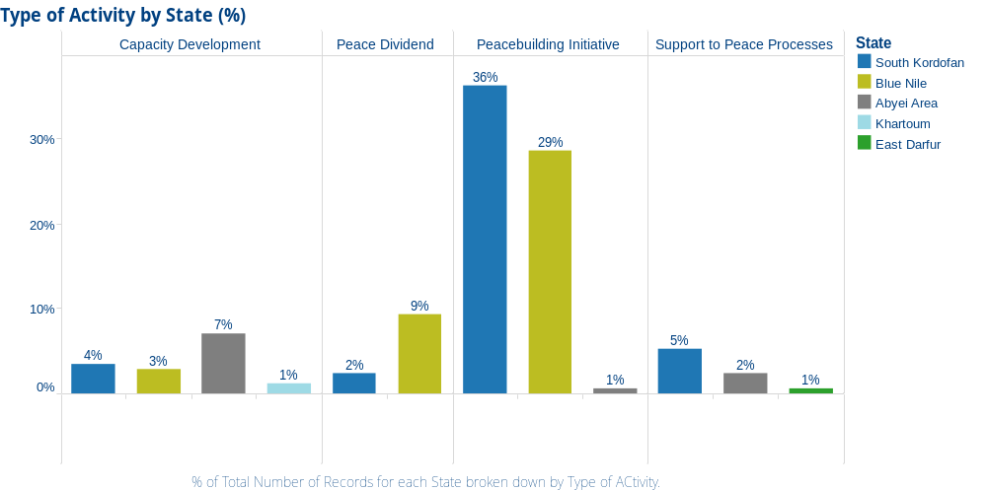

% of Total Number of activities for each State broken down by Type of Activity

In summary, the most significant impacts of JCRP in 2013 include;
- The capacity of the Blue Nile Peace Council is increasing, as evidenced by their growing ability to effectively lead and implement peacebuilding activities, with the need for support from JCRP decreasing over time;
- The Peace Council, with support of JCRP, has been instrumental in establishing 27 local level peace committees along three migratory routes in BNS. These local committees are increasingly playing an important role in local level conflict resolution. With further support and coordination, there is potential for this new network to collaborate in establishing a community based early warning system;
- Conflict has been reduced and livelihoods improved in the Lagawa and Al Sunut area of WKS. These areas provide an excellent example of the gains that are possible with sustained and coordinated peacebuilding efforts over time;
- Conflict has also been reduced along the migratory routes in Blue Nile State due to the process of corridor demarcation/compensation in tandem with the delivery of peace dividends. The PC advised incident reports to police have dropped from around 400-500 each harvest season to less than 30 in the recent harvest season;
- Misseriya re-opened markets that had been closed for more than a year as well as water sources along the Western corridor to Rizegat communities in WKS as a result of six community forums, culminating in a one day conference at which diya (blood money) was paid to compensate for loss of lives, with both communities affirming their commitment to the Misseriya-Rizegat Reconciliation Agreement.
- The range and number of community stakeholders committed to peacefully resolving conflict grew as a result of expansion into new areas, training a broader range of community actors and through the highly successful Universal Peace Day in BNS in which 7500 men, women and children participated and;
- More CSOs are applying Do No Harm and Conflict Sensitivity in their work as a result of trainings provided by JCRP, with positive peacebuilding impacts on local communities.
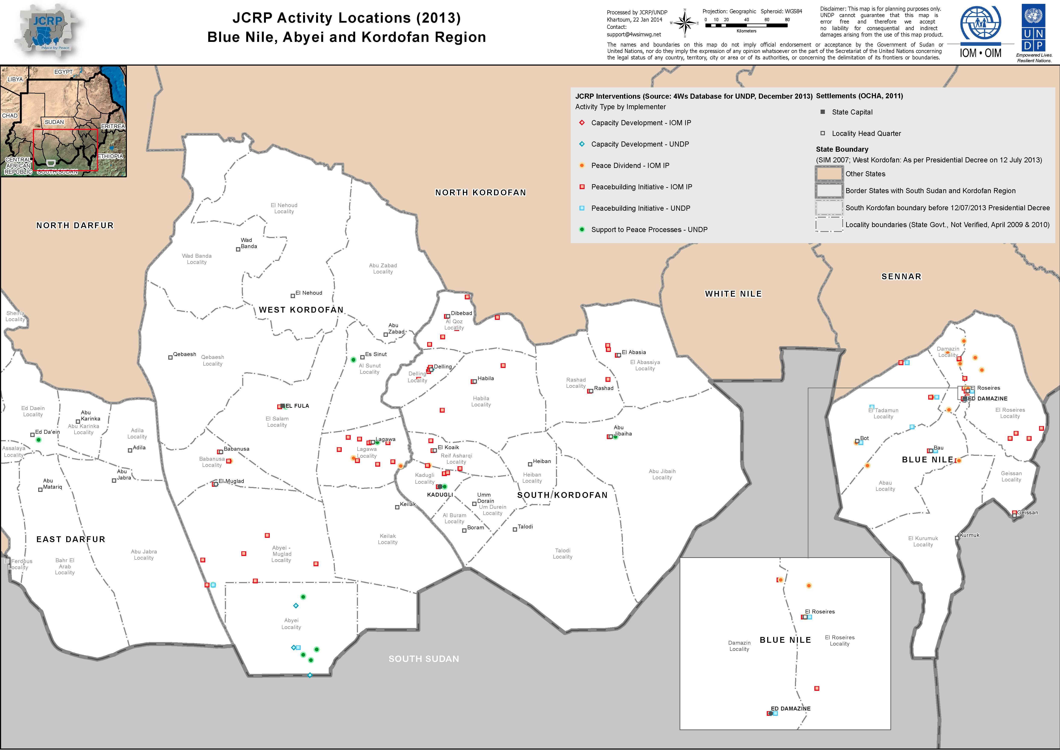
Section 2: Progress against each output

The following sections provide an overview of progress towards the four project outputs as per the Annual Work Plan (AWP) 2013.

Project Output 1: Effective and sustainable Institutions are in place in support of community-level conflict resolution and prevention.
Output indicators | Targets | Progress against targets
- New members of RPCM, PC and Native Administration trained in Conflict Mediation and Do No Harm.  - # of functioning conflict resolution mechanisms (Government and Civil Society (at all levels).  - % of community members indicating effectiveness of the RPCM and PC  - % of Community level peace actors trained by JCRP that report using skills and tools gained through JCRP supported trainings in the 3 months following completion of training. | Target: All new members of the RPCM, PC and Native Administration trained on Conflict Mediation and DNH.  Baseline (2012): Trainings had been provided to the RPCM and PC  Target: Two  Baseline (2012): Two  Target: 70% of community members rate RPCM and PC as either effective or very effective.  Baseline (2012): Not available  Target: 70% of community level peace actors trained by JCRP report using skills and tools gained through JCRP supported trainings in the 3 months following training.  Baseline: Not available | - All new members of the PC were trained in conflict transformation & peacebuilding training in Sept 9-12. Training for the newly formed Peaceful Coexistence and Social Peace Committee (formerly RPCM) is planned for the first half of 2014. (Source: Participant Registration sheets, Training completion reports, Training feedback forms)  - Two - The BNS Peace Council is still in place. The RPCM was dissolved and replaced with the Peaceful Coexistence and Social Peace Committee in November 19, 2013  - 73% of community members surveyed at a community consultation in Delling, SKS responded that the RPCM were effective or very effective in contributing to conflict resolution in their community. Surveys were not able to be carried out in other parts of SKS due to security/access concerns. A mission was also planned to BNS by the University of Khartoum (Peace Research Institute) – but due to delays in receiving HAC approval, will now take place in February, 2014.  - 93% of training participants surveyed reported using skills gained through JCRP trainings in the 3 months following training. (Source: Telephone surveys conducted with 25% of participants 3 months after completion of trainings)

Project Output 1 activities and results:

The capacity of the Peace Council in Blue Nile State continues to grow through the provision of formal trainings and on-the-job support from the 3-member JCRP team based in BNS. Increasingly, the PC is taking a lead role in the planning, implementation and monitoring of activities as well as communications and coordination with key stakeholders on the ground, with the level of support required from JCRP reducing over time. This is evidenced in the recent successes of the PC in establishing 27 local level peace committees along the migratory routes in BNS. These local level institutions are playing an important role in resolving local level conflicts. With further support and coordination, there is potential for this new network to collaborate in establishing a community based early warning system.

Prior to the dissolution of the RPCM, JCRP had also been working closely with the RPCM members and is now in the process of building relationships with the new four member Peaceful Coexistence and Social Peace Committee (PCSPC), laying the ground for future collaboration and capacity development efforts. Due to the unresolved status of Abyei, no State-level peacebuilding mechanism was formed in Abyei during the reporting period.

JCRP also engaged a larger and more diverse range of community level peacebuilding actors through their participation in formal trainings, community dialogues and workshops. Apart from increasing the knowledge and skills of participants, the trainings are also having positive flow-on effects through participants;
- Sharing learning gained in trainings with their families, friends and colleagues
- Volunteering their time and skills to community level peacebuilding activities and;
- Initiating their own peacebuilding activities in their own communities.

For example, following the training of 50 youth in conflict analysis and peacebuilding, the participants were able to facilitate intra-community dialogues in several counties in Abyei, with limited support of JCRP. Likewise, further to the training of 45 Ngok Dinka chiefs in Abyei, participants formed a nine member Ngok Dinka Administration Peace Council in Abyei, who are now playing a key role in facilitating peace negotiations and reconciliation processes.

Success Story: Dinkga Ngok Chiefs put learning gained from training into action through the formation of 16 Peace Committees in Abyei Area
Following a JCRP training of 45 Dinka Ngok chiefs in peacebuilding and negotiation skills in August, the trained chiefs went on to develop 16 Peacebuilding Committees in Abyei, including one High Committee for Peace Building, the Abyei Women’s Peace Committee and 14 local level peace committees. The role of these committees will be to support local conflict resolution, to collaborate in the development of an early warning system and to equip local people with the skills to eventually undertake intra-community dialogues; a step which both Dinka and Misseriya communities recognize is an essential precursor to peaceful coexistence. To further support the steps taken by the Dinka leaders, JCRP provided training for members of the newly formed peace committees in Peacebuilding and the development of conflict early warning systems in December. Similar work in building capacity of community leaders is also underway with Misseryia communities in the North of the Abyei Area.
Here’s what the Dinka Nogk Paramount Chief / Chairperson of the Abyei High Committee had to say during a workshop in support of the peace committees held in Abyei in December.

It is a great milestone for us to talk about peace and to establish Peace Committees among our communities. We known too well the impact of conflict. Let us unite for peace and start building peace in our communities. We need peace with all our neighbours, including the Misseriya. It is possible to live in peace with our neighbours. A good example is the improved relations in the North. They fought war for 21 years, but were able to resolve their issues. We have to make similar efforts to live in peace with our neighbours. Let us take action to support our people to move in the same direction

Photo Credits: UNDP
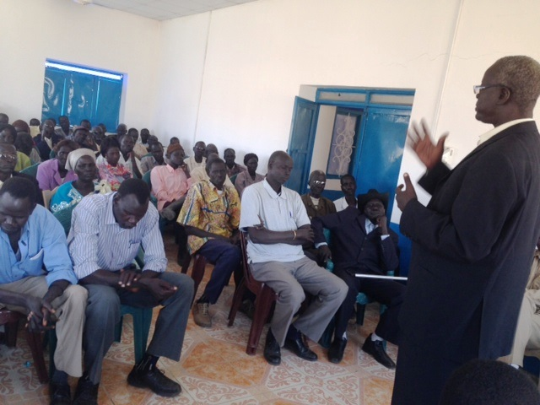
Figure 1 Photo Credits: UNDP

Project Output 2: Immediate and emergent flashpoint conflicts mitigated through inclusive peace processes.
Output indicators | Targets | Progress against targets
- % of JCRP supported peace processes continuing to hold six months after their conclusion.  - % of peace process participants representing vulnerable groups (women, youth).  - Degree of resilience to state-wide conflict as a result of peace processes. | Target: 80% of peace processes designed and implemented in 2013 continue to hold.  Baseline (2012): 85%  Target: 50% of peace process participants represent vulnerable groups.  Baseline (2012): 10%  Target: 80% of peace process participants report they are less likely to join state-wide fighting after the peace process.  Baseline (2012): Not Available | - 93.75% or 17/18 JCRP supported peace processes continue to hold six months after their conclusion. (Source: Government peacebuilding mechanisms, peace ambassadors and other key stakeholders)  - 25% - A total of 2236 people participated in JRCP Peace Process Activities (Conferences and Workshop). Of these 552 or 25% were female. (Source: Participant registration sheets, Activity reports)  - 0% - Due to the political sensitivities referred to in Section V. on Challenges, this indicator was not monitored.

Project Output 2 activities and results:
Steady progress was made towards Output 2 in 2013. A number of selected peace activities were implemented in partnership with Government counterparts and civil society organizations in response to flashpoint conflicts in the Three Areas. These included;
- The signing of a reconciliation agreement involving three main Misseriya clans in Ed Daein (East Darfur) in March 2013 represented a major achievement, signaling a new beginning for clan relations following intense fighting in El Fula earlier in February, which led to thousands of people being displaced from their homes;
- Misseriya reopened markets that had been closed for more than a year as well as water sources along the Western Corridor, to Rizegat communities in West Kordofan as a result of six community forums conducted by the Meiram Peace Committee (with support of JCRP), culminating in a one-day conference attended by 200 community members at which diya (blood money) was paid to compensate for the loss of lives, with both communities affirming their commitment to the Misseriya-Rizegat Reconciliation Agreement;
- Support was also provided to the Goodwill Committee on Misseriya Reconciliation who conducted follow-up dialogues between Saror-Heiban tribes in three localities in December, resulting in the Government committing to follow up the payment of Diya, the Awlad tribe relocating to a new area and a commitment both tribes to honor the agreements reached and;
- Following the successful Reconciliation conference for the Daju-Eininat in late 2012, follow-up workshops were completed, with positive signs of improving relations between the two communities, evidenced by both communities returning to their joint village and re-establishing their joint markets. A Peace Dividends workshop was also conducted in Lagawa in May to identify peace dividend priorities, with one water-yard already constructed;
- Agreement to the cessation of hostilities was also reached between Kaw Tribes during the Abu-Jibaiha Peaceful Coexistence Conference conducted in SKS in December, with the Government furthermore committing to the provision of basic services;
- Further to the successful reconciliation process of Abujunuk-Umsaleem tribes in WKS, a peace dividends workshop was held in December, 2013. Involving members of both tribes in a process of collectively envisioning their future not only resulted in the identification and prioritization of peace dividends but also served to strengthen relationships and trust;
- Four intra-community dialogues were conducted in Abyei, three with Ngok Dinka and one with Misseryia community leaders in Abyei, further laying the ground for the possibility of inter-community dialogues in the future;
- The completion of participatory dialogues along the migratory corridors in Blue Nile which resulted in agreement over the placing of stones to demarcate the corridor and the compensation to affected farmers. Eighty percent of the corridor demarcation process has now been completed with local authorities already reporting a reduced incidence of farmer-pastoralist conflicts;
- A highly successful Universal Peace Day was celebrated in Blue Nile State, with around 7,500 people participating.

Success Story: Universal Peace Day, Damazine, Blue Nile State
The Universal Peace Day was celebrated in Damazine, BNS on the 21st of September, 2013. The event brought together over 7,500 men, women and children in a full day of events with the sole purpose of focusing on the building of peace. Due to the close collaboration and shared efforts of the Peace Council, the Minister for Culture, Youth and Sports, Community Leaders, Youth and Women’s Unions, Native Administration and government authorities and the South Kordofan Football Union, the day was a great success. For those who attended, the
Universal Peace Day was an opportunity to leave aside differences, to come together, to share in each other’s culture, music, and dance and enjoy a football match. Seemingly ordinary things, yet in the context of Blue Nile State – quite extraordinary!

Gashra Saadalla is from Rosaries Town. Here’s what she had to say about the Universal Peace Day.

 For me, the word Peace is a wonderful word; it makes one feel happy and have hope. Blue Nile State has been trapped in war since the early 1980’s and enough is enough! Thanks to the Peace Council for this opportunity to come together. I see people are happy and interacting and chatting with each other because of the Universal Day of Peace and the hope that comes with it. 

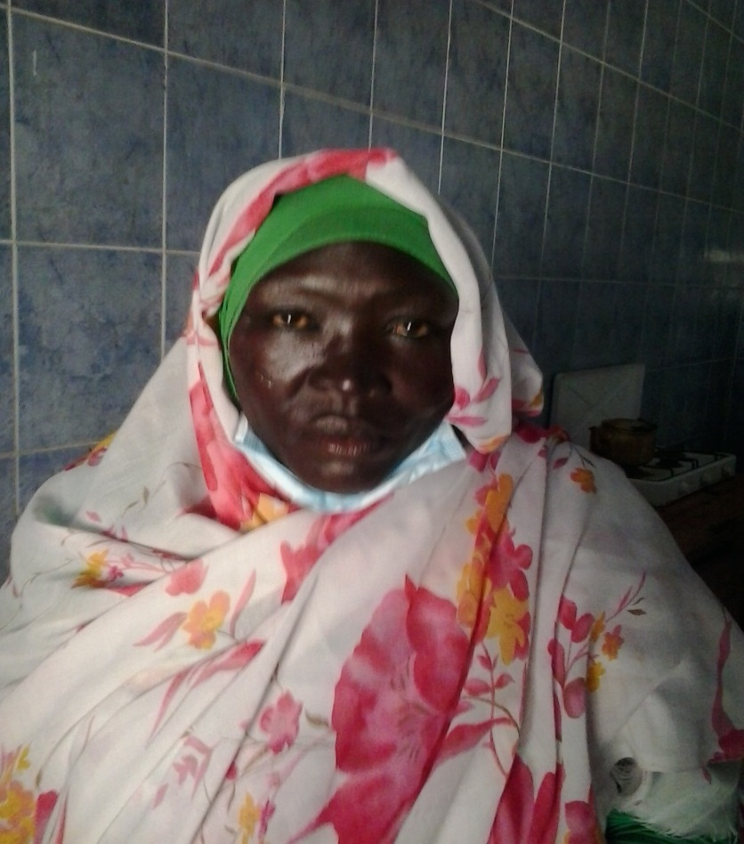
Photo Credits: UNDP

A group of women from the Ingasana tribe expressed their willingness to participate in the peace process by convincing their sons, husbands and brothers to stop fighting. One of the women, Mona added;

If it were not for the PC we were about to lose hope and think just of war. Today we realised there is another option that can accommodate all people, regardless of their background, in one place as were are now in the BNS Stadium. That option is “Peace”

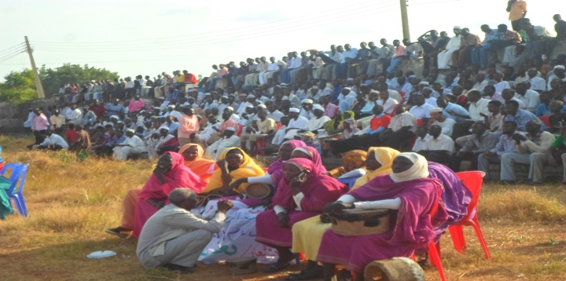
Photo Credits: UNDP
Project Output 3: Targeted dividends delivered to communities in accordance to priorities identified during local processes
Output indicators | Targets | Progress against targets
- # of beneficiaries directly benefiting from peace dividend delivery.  - % of beneficiaries reporting that peace dividend delivery has made it more likely they will remain at peace. | 1) Target: 67,000 people benefiting from peace dividend interventions  Baseline (2012): Not available as contracts were only awarded in Q4, 2012.  2) 80% of beneficiaries report that peace dividend delivery has made it more likely they remain at peace.  Baseline: Not available | - 51,300 beneficiaries (11,286 males, 15,903 females, and 24,111 children)  - 0% - No data available yet as the relevant peace dividends were complicated toward the end of the Year 2013.  *94% decrease in the number of pastoralist-farmer conflict incidents (from 400-500 to 30) reported by Peace Council along the cattle migration corridor newly demarcated through JCRP.

Project Output 3 activities and results:
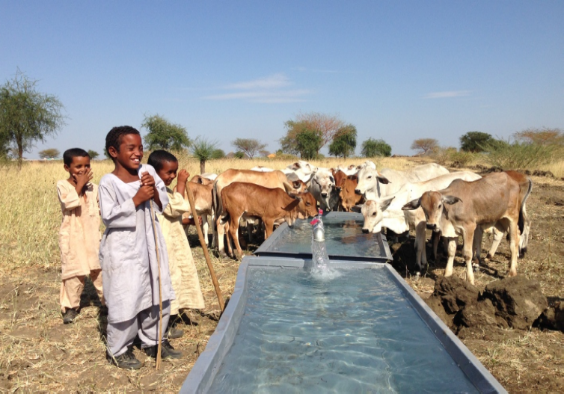
Activities under Output 3, “Targeted peace dividends delivered to communities in accordance with priorities identified during local peace processes,” were identified by communities, each of which were designed and tailored to the specific needs of the communities previously in conflict, to solidify their reconciliation processes.
Children of nomadic tribes water their cattle at the
Newly-built Barakat Water Yard – Photo Credits: IOM

From January to December 2013, as a result of four peace conferences hosted by local counterparts in SKS and BNS with JCRP support, plans were created for construction / rehabilitation of seven water yards, six hand pumps, two schools, and the demarcation/compensation of cattle migration corridors. These peace dividends serve to reduce competition over limited water and land resources – one of the most common triggers of communal discord in these regions. During 2013, five water yards, two hand pumps, and one school were completed, benefiting approximately 26,400 people. Approximately 110 km (80% of the planned length) of cattle migration corridor was demarcated based on the dialogues initiated by the PC and State Ministry of Agriculture. The second school is due for completion by Jan 14, 2014.

To gauge the impact of these peace dividends on the consolidation of communal stability, a number of monitoring missions comprising focus group discussions with beneficiaries were conducted in SKS and BNS. The peacebuilding effects of the peace dividends were evident: communities that previously experienced competition over natural resources, sometimes with casualties, expressed their satisfaction with the peace dividends in helping them live more peacefully with their neighboring communities. The livestock corridor demarcation / compensation proved particularly beneficial, with the Blue Nile Peace Council reporting a dramatic reduction in the number of disputes between farmers and pastoralists resulting in reports to police.

Success Story: Conflict reduced in Blue Nile State as livestock migration corridors are demarcated and affected farmers compensated
For centuries, pastoralists have migrated with their livestock in search of grazing land along well-trod corridors in Blue Nile State. Over time, with the expansion of mechanized farming, increased livestock densities, as well as variable rainfall and recurrent drought, competition over scarce land and water resources intensified. When South Sudan became Africa’s newest nation in 2011, the borders were closed, further reducing the land available to pastoralists. With both pastoralists and farmers reliant on access to land for the survival of themselves and their families, these tensions often resulted in conflict. Farming crops were damaged as pastoralists were forced to graze livestock on farm land, reducing the yields and ultimately, the food security of farming communities. Police routinely received reports of crop damage or conflict between farmers and pastoralists, with members of the Native Administration called upon to mediate the disputes. Whilst a short-term solution was often found, problems inevitably re-arose, again and again. What was needed was a long-term solution.
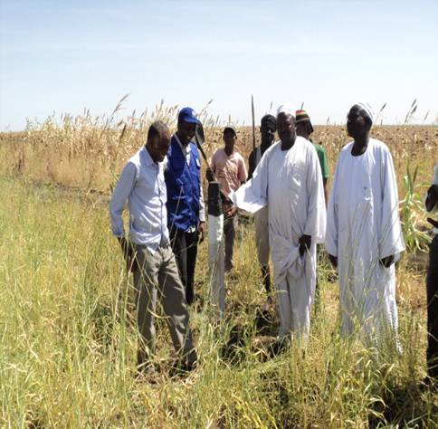
Farmers actively engaged in the process of monitoring fixation of stones along the agreed demarcation routes, Photo Credits: IOM

Addressing conflict between farmers and pastoralists was one of the main objectives of the Bau Conference held in 2010 and the Damazine Conference in 2012. One of the key agreements reached at these conferences was that traditional corridors should be clearly demarcated, with affected farmers, duly compensated. With JCRP’s support and based on the agreements reached, 109 kms of migration corridors have now been demarcated, with affected farmers compensated. Mr Ibrahim Shaga, a farmer and father living in Agadi West, BNS, readily gave up a portion of his land in favor of the migration corridor, commenting that “We are very happy about this work because it means the animals will no longer enter our land and we can grow crops safely without fear of damage by animals.”
The Blue Nile Peace Council reported that, as a result of the corridor demarcation and compensation process, the number of disputes between farmers and pastoralists reported to police has plummeted. They advised that in the previous harvest seasons, around 400 - 500 reports on average were made to police each season. As of November 2013, less than 30 reports had been made to the police that season. Dr. Adam Abaker Ismail, General Secretary of the Peace Council and former Minister for Agriculture commented that “if left unchecked this situation could have ended up like the conflict in Darfur”. He added that during his time as Minister for Agriculture, “between July 2012 and July 2013, there were around 20-30 deaths related to farmer-pastoralist conflict and that since the demarcation started this autumn, there have been no reports of deaths”. Mr Abdulrahman Hassan, Head of the Pastoralists Union added that since the demarcation “No farmer can come and say someone has destroyed their crop, the pastoralists now have enough land without going on to farming land”.
Mr Ahmed Alawad Abusas, the Head of the Department of Range and Pastoralists, Ministry of Agriculture and Animal Resources detailed what he saw as some of the key factors contributing to the success of the corridor demarcation process. These were; selected routes were based on agreements reached in earlier conferences; police and other witnesses were engaged to minimize potential disputes over borders; the clear marking of both demarcated and compensated land; the participatory involvement of all key stakeholders; the fact that fair compensation was paid to affected farmers; the good coordination between the agencies involved, and; the fact that lessons learned from previous attempts were drawn upon to avoid making similar mistakes.
The map on the following page provides a visual representation of the demarcated livestock migration corridor and peace dividends in BNS.

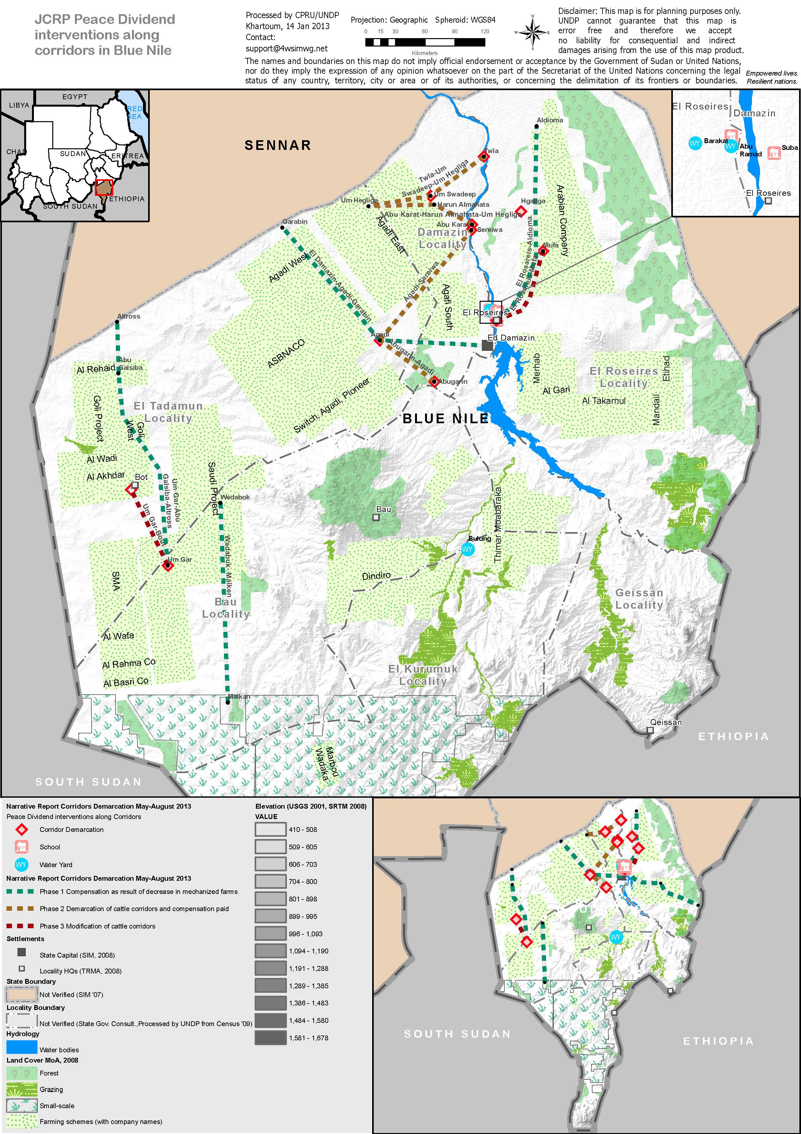
Project Output 4: Immediate and emergent flashpoint conflicts mitigated through inclusive peace processes.
Output indicators | Targets | Progress against targets
- #of individuals directly benefiting from catalytic peace building initiatives.  - Degree of resilience to state-wide conflict as a result of catalytic peacebuilding initiatives. | 1) Target: 15,000  Baseline (2012): Not available as contracts were only awarded in Q4, 2012  2) Target: 80% of peace process participants report they are less likely to join state-wide fighting after the peace process  Baseline: Not available | - Total 19,546 people (11,306 males and 8,240 females) benefited from 19 peacebuilding projects implemented in SKS and BNS. (Source: Implementing partner reports)  - 0% - Due to the political sensitivities referred to in Section V. on Challenges, this indicator was not monitored.

Project Output 4 Activities and Results:

Through the JCRP grant scheme, a total of 19 projects were funded in BNS, SKS, and WKS, in support of enhancing communal capacities to deal with disputes and nurturing resilience to state-wide conflict, especially among youth. Nine of the 19 grant projects were funded in 2012 through the 1st Call for Proposals (3 for SKS; 2 for WKS; 4 for BNS) and 10 projects through the 2nd Call for Proposals opened in 2013 (2 for SKS; 2 for WKS; 1 covering both SKS and WKS; 5 for BNS). Below is a summary of the implemented projects and locations.

First Call for Proposals

State and Localities | Implementer Name | Activity Description
SKS: Kadugli, Rashad, Abbasiya | Sudan Peace and Development Organization (SPDO) | Conflict Mitigation and Peace Dividends for South Kordofan Youth
SKS: Algoz, Elreef ElShargi | Near East Foundation (NEF) | Resource, Economic Security and Peace in South Kordofan State
SKS: Delling, Algoz, Habila | Gender and Peace Building Center | Create Sustainable Peace Building Window
WKS: Bababousa, Elsalam, Muglad | MUZAN Organization for Peace Building and Development | Bridging the gap of trust and confidence between Youth and native Administrative Leaders in West Kordofan
WKS: El-Fula, Lagawa | Badya Centre for Integrated Development Services | Our voice, our future: youth building peace in South Kordofan State
BNS: El-Rosseries, El-Tadamon, Damazine | Women Initiative Group (WIG) | Towards Peaceful Coexistence in Blue Nile
BNS: El-Rosseries, El-Tadamon, Damazine, Kurmuk, Baw | Youth Forum Organization (YFO) | Youth Leadership for Peace Building in Blue Nile
BNS: Damazine, Rosseries | DOSHA for Social Development Organization | Local Audio Dictionary for Conflict and Peace Project
BNS: Damazine, Rosseries, Tadamon | Sudanese Development Initiative (SUDIA) | Promoting peaceful coexistence along Garabeen – Menza livestock route in BNS

Second Call for Proposals

State and Localities | Implementer Name | Activity Description
SKS: Kadugli, Abbasiya, Algoz | Sudan Peace and Development Organization (SPDO) | Conflict Mitigation and Peace Dividends for South Kordofan Youth
SKS: Delling, Algoz, Lagawa, Habila | Gender and Peace Building Center (GPBC) | Create Sustainable Peace Building Window
WKS: Lagawa | Islamic Relief Agency (ISRA) | Conflict Risk Reduction Project in Lagawa
WKS: Muglad | El Goni Charitable Organization (ELGONI) | North Abyei (Muglad Locality) Community Peaceful Co-existence Initiative
WKS and SKS: Al Fula, Abbasiya, Rashad, Abujubeiha, Habila | Sibro Organization for Development (SIBRO) | Establishment of Community-based Conflict Observer Committees
BNS: Damazine, Baw, Gissan | Sudanese Open Learning Organization (SOLO) | Sustainable Social Cohesion and Peaceful Co-existence in Blue Nile through Community Participatory Approach
BNS: El-Rosseries, Damazine | DOSHA for Social Development Organization | Youth Employment for Conflict Reduction and Peaceful Co-existence
BNS: El-Rosseries, Tadamon, Damazine | Sudanese Development Initiative (SUDIA) | Livelihood and Peace Building Initiative along Garabeen – Menza Livestock Route/BN
BNS: Damazine | Islamic Relief Agency (ISRA) | Conflict Risk Reduction Project in (Rosseries, Bau and Geissan localities of BNS
BNS: Tadamon, Damazine, | Sudan Peace Development Organization (SPDP) | Peace Building through Livelihood and Resources Management

The projects listed above can generally be categorized into three different approaches to promoting stability, reconciliation and peaceful coexistence, with some projects combining all the three;

- “Dialogical” projects that are designed to provide platforms for reconciliation between divided communities and to enhance capacities of communities to address inter/intra-communal disputes. They also seek to engage and mobilize previously marginalized members of communities, such as women and youth, as promoters of reconciliation and coexistence;
- “Livelihood” projects that are designed to provide women and young people with tangible income generating skills so they would be less prone to join state-wide conflicts as a means of making a living and;
- “Natural resource management” projects, which are similar to dialogical projects in that they train communities in managing shared natural resources.

A range of activity and M&E Reports submitted by grantees, comments by Governmental counterparts, the results of an Evaluation conducted in December and IOM staff project monitoring visits confirmed that all projects implemented under Output 4 were designed on the basis of sound conflict analysis and were relevant to the needs they were intended to address. For instance, Muzan succeeded in bringing together Baraka and Seniataya communities to meet with each other, after nine months of hostility. Particularly notable was the fact that Muzan trained youth who had been having a destabilizing effect on communities, also involving them in the Native Administration, thereby turning potential “spoilers” into advocates for peace. Their success resulted in an official invitation from Meiram and Debab localities, which were initially not included in Muzan’s targeted areas, to train their young people in conflict resolution skills, as a result of their JCRP supported activities. They received further invitations from El-Biriasa Oil Field Security Management Office, as well as the Balila Oil Field to conduct similar activities to help them nurture better relationships with local youth.

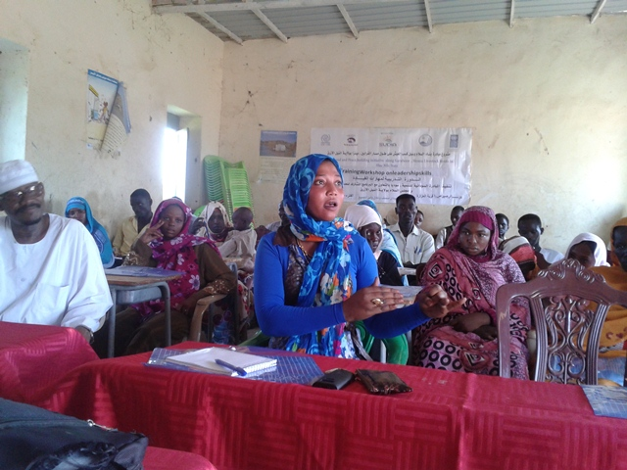
Sudan Peace and Development Organization (SPDO) trained 254 young people in repairing mobile and other communication devices. The youth were also trained in market analysis and business skills. As a result of this training they established income generating businesses, with the support of local authorities. In Algoz locality, the Locality Commissioner allocated land for trained youth to set up a shop, without a rental charge for 10 years, even though the common practice in the area was to lease shops for 5 years. In BNS, Sudan Development Initiative (SUDIA) implemented a hybrid project focusing on capacity building of Native Administration, training members of water management committees, and women in food processing skills. Their skills quickly yielded positive impacts in terms of improved livelihoods.
The Natural resource management approach to conflict reduction is exemplified in the work of the Near East Foundation’s (NEF) project which trained tribal leaders in addressing disputes arising over the use of water sources and grazing land in SKS. As a result, when quarrels between the Toxoana and Abuagal communities over cattle raiding escalated into both pulling out guns to threaten each other, leaders trained by NEF stepped into successfully mediate the dispute. They also assisted in helping communities calm the involved youth down, before assisting them in reaching a workable solution regarding the cattle theft, which was shared with and supported by the local authorities.
Leadership skills training conducted by SUDIA,
Blue Nile State – Photo Credits: IOM

IV. Monitoring and Evaluation

Monitoring and Evaluation (M&E) activities are critical to understanding the operational context, the programme’s progress, the impact of context on results and vice versa as well as informing future directions. Considerable efforts were made in 2013 to strengthen JCRP’s M&E system through the standardization and systemization of monitoring and reporting tools and templates and the articulation of a more comprehensive M&E Approach for JCRP. Below is a summary of the M&E activities undertaken in 2013 along with key outcomes of each activity.

Month | Monitoring Activity / Outcomes
January – Dec 2013 | Monitoring Visits to IOM Implementing partners were conducted and documented by JCRP staff to validate activities in line with implementing partner project plans.
February 2013 | Two monitoring visits were conducted by IOM technical staff in with the objective of monitoring the construction of a Women's center implemented by the Gender Peace Building Center (GPBC) in Delling locality, SKS. 25% of the total works was verified to be executed, consistent with the submitted work plan. Three additional follow-up monitoring missions were conducted in subsequent months for this activity until the main structure was completed in July.
March 2013 | A mid-term review of JCRP was carried out by Helena Puig Larrauri over the course of a three week mission in Khartoum in February, 2013. The Report provides her assessment of the strategic relevance of JCRP, a review of JCRP performance and recommendations regarding JCRP expansion and replication. In light of the report’s recommendations and the JCRP’s own experience and lessons learned, shifts in the strategic approach were made, with relevant adjustments likewise made to the Annual Work Plan.
August – Dec 2013 | Commencing in August, a Standard Training Evaluation form was developed for completion by all participants of Peacebuilding/Conflict Sensitivity/Do No Harm Trainings. The forms have now been used by participants in 10 trainings, with 90% of training participant rating the overall quality of the training as either Very Good or Excellent, with 95% Agreeing or Strongly Agreeing that they will be able to apply what they have learnt in practice.
August 2013 | A field mission was undertaken to El Damazine locality, Blue Nile State by IOM technical staff. The objective of this mission was to Monitor construction progress of the water yard in Abu Ramad. The mission verified that 20% of the construction water yard has been reached.
September 2013 | A field mission took place in September, 2013 to Kadugli, SKS by IOM technical staff. The objectives of the mission were to carry out a coordination meeting with 5 IPs in SKS and to attend a workshop conducted by SPDO. The field mission also aimed at Visiting 3 IP’s offices in SKS to discuss M&E methodology and other operational matters.  IOM also monitored the progress of the water yard construction works conducted by WES. Discussions were held with regards to the plan of the hygiene, hand-pump mechanics training and community management to complement the hand pump construction work taking place in Jabarona, Bajon, and other communities through the Serir-Batran Peace Conference.
September 2013 | At the request of the European Union (EU) Delegation in Sudan, Ms Inge Remmert-Fontes carried out a field visit to Khartoum between September 8-12 to assess the ongoing relevance and effectiveness of two programmes in Sudan, one of which was the JCRP. The JCRP collaborated closely with the consultant, providing information as required and organized a focus group discussion with 11 Grantees implementing activities under Output 4. A report was prepared which, based on current conflict analysis confirmed the ongoing relevance of JCRP in terms of alignment with political intentions of peacebuilding at state level, Government policies and the needs of beneficiaries. The report also highlighted areas of success and failure along with recommendations for the future.
October 2013 | A “Story of Change” was developed based on interviews conducted with participants at the Universal Peace Day celebrations conducted in Damazine. The story was forwarded to donors and uploaded to the UNDP website.
October- Nov 2013 | A consultant was engaged by IOM to undertake an evaluation of the impact of Output 4 grant activities and the quality of the grant management process administered by IOM. The major findings of this evaluation were that the activities contributed to stability and improved communal relationships in the areas of intervention. The evaluation also highlighted the important role of the PC in facilitating the implementation of programme activities through effective coordination at the ground level. Best practices and lessons learnt gathered is informing ongoing programme planning for Phase II. A survey was also conducted of grantees from the 1st and 2nd Calls for proposals. Grantees rated the quality of the technical advice on CS, DNH and PCM provided by IOM/UNDP as either “Very Good” or “Excellent” while 17% of the partners rated the JCRP technical assistance as “Fair”.
November 2013 | A mission to Blue Nile State was carried out to conduct capacity building activities with the Blue Nile Team and Peace Council on M&E. Interviews were also conducted with key informants with regards to the impact of the corridor demarcation /compensation process in Blue Nile State.  The Blue Nile Peace Council were supported to undertake a Team Self Review for the purpose of reflecting on achievements to date, challenges, learnings and the identification of priorities for future action. The tangible output of the process was a Mini-Report summarizing the team’s shared assessment in response to the focal questions, which will be used to aid the PC’s annual planning process.
November 2013 | A field mission took place in November, 2013 to El Damazine locality, BNS by IOM technical staff. This mission verified the completion of the water yard in Barakat Settlement, El Damazine locality, as well as monitoring the ongoing construction of two schools in Abu Ramad in El Damazine Locality and Soba in El Rosseries Locality. The mission included monitoring of the ongoing fixation of stones for corridor demarcation and compensation.  For activities under Output 4, IOM monitored the implementing partners’ activities on the ground. IOM held a meeting with several of the partner organizations in their offices to discuss operational matters. IOM also attended a number of cultural events in celebration of a “Peace Day” organized by ISRA in Kor Maganza settlement. The SOLO organization also conducted a public event in Tologosh around the theme of ‘Community Stabilization’.
November 2013 | A Team Self Review was conducted with both IOM and UNDP staff of JCRP. The review focused on developing a collective response to three key questions;  - Are we doing what we said we would do? If not, why not?  - Are we making any difference? If so, what?  - Are we doing the right things? What should we continue, stop or start?  The key lessons learnt and recommendations were summarized in a Mini-Report and were used to guide planning for Phase II.
December 2013 | A verification mission took place in December, 2013 to El Damazine locality, Blue Nile State, where all the activities under Outputs 3 and 4 in Blue Nile State were in their final stage of completion (both hard and software components).  IOM confirmed that the contractor handed over Bulung Water Yard in Kurmuk locality to the communities, in addition to following up the two schools in Abu Ramad village in El Damazine locality and Soba village in Rosseries locality. IOM monitored the ongoing process of fixation of stones for Demarcation and Compensation activities.  Output 4 activities were verified to be in their final stage of completion. IOM also observed activities conducted by two IPs during the mission. The first was an Open Day and Graduation Ceremony conducted by DOSHA. The second was a vocational training implemented by SOLO, teaching skills in the manufacture of traditional products such as locally made perfumes, hair oil, and incense.
December 2013 | Interviews were conducted with two participants in the Peacebuilding and conflict transformation Training for Native Administration conducted in Muglad, WKS in December. The interviews took place in Khartoum. Both participants spoke very highly of their experience in the training and of the impact the training was already having. One of the participants commented that even during the training itself (in the breaks) that they started applying the tools they were learning in the training to address three real life conflicts currently affecting their communities. He added that; ‘One of the tools we learned was the conflict analysis tree, about studying the root causes of conflict – now before we try to resolve a conflict we try to analyze the conflict before trying to come up with solutions’.
December 2013 | The risk management matrix was reviewed and updated
December 2013 | The University of Khartoum (Peace Research Institute) conducted a participatory monitoring exercise, on behalf of JCRP, in Delling, SSK. A range of methodologies were utilized, including Participatory Rural Appraisal tools such as time-line, focus group discussion, ranking exercises and impact mapping. Unfortunately, due to security concerns, community consultations also planned for x, x and x localities were cancelled. Community consultations planned for BNS were also planned, but due to delays in HAC providing the necessary approvals, the mission is now planned for February, 2014.
December 2013 | A participatory monitoring exercise was conducted in Abyei, using the same methodology as that used by the University of Khartoum in Delling. The results of this exercise are expected by the end of January, 2013.
December 2013 | A comprehensive M&E Framework outlining the monitoring arrangements, approach and methodologies for Phase II of the project has been developed in line with the revised Results and Resources Framework. The Framework provides detailed guidance for using the standardized monitoring and reporting templates as well as for the development of Stories of change, case-studies and the facilitation of reflective review processes. It also spells out the monitoring and reporting responsibilities and time-frames.

V. Key Challenges, Lessons Learned and Recommendations

Key Challenges

The key programmatic challenge during the reporting period related to ongoing security issues resulting in restricted or limited access to the Three Areas. There were a number of key developments during the reporting period that resulted in a heightening of tensions. These include;
- The killing of the Ngok Dinka Paramount Chief in Abyei in May
- The change in administrative divisions and the reinstatement of West Kordofan
- The dissolution of the RPCM and its replacement with a newly formed Peaceful Coexistence and Social Peace Committee (PCSPC)
- The hosting of a unilateral referendum in the Abyei Area in October resulting in a further increase in tensions between communities
- Nationwide inflation and civil unrest and in Khartoum in the wake of the lifting of fuel subsidies in October
- Further escalation of conflict between the Sudanese Armed Forces (SAF) and the Sudan People’s Liberation Army – North (SPLA-N) in South Kordofan and Blue Nile States

The key challenges experienced by JCRP and actions taken to address these challenges are detailed below.

Restricted access
Limited access to the project area by staff remained a challenge, with delays in the obtaining of permits also resulting in delays in implementation as well as challenges in monitoring programme activities. National IOM staff were only allowed access to BNS in August 2013, while international IOM staff have not been able to visit the State in 2013. For UNDP staff, even when access was granted to Kadugli and Damazine towns, access to areas outside of these capital cities remained restricted. National UNDP staff were able to travel to the main towns in SKS and BNS, but security incidents continued to restrict their travel to more remote locations. In Abyei, national staff were evacuated following the killing of the Ngok Dinka Chief, who were unable to return during the reporting period. To cover the gap created by absence of national staff, an international peacebuilding specialist was deployed to Abyei on an extended mission and will remain posted there throughout Phase II.

Political sensitivities
State-level priorities are driven by the SAF – SPLA/N conflict, which can at times result in difficulties for partners working in peacebuilding. All peacebuilding and conflict reduction work is considered highly sensitive by Government authorities. This impacted on JCRP’s ability to access beneficiaries for monitoring purposes and also resulted in two of the project indicators not being monitored. Over the course of 2013, JCRP sought to address this challenge through engaging Government counterparts in the planning, implementation and monitoring of activities and obtaining all necessary approvals from National Security and Military authorities as required.

Reduced capacity
The conflict has led to changes in state Governments, and this turnover has affected the technical capacities that the programme had supported to date. A number of international NGOs working on peace building in the Three Areas are unable to access or work in South Kordofan and Blue Nile States. While some national NGOs and potential partners continue to work in the area, others are unable to due to logistical and/or security reasons. In addition, some national CSOs have had difficulties obtaining technical agreements with the relevant authorities. JCRP has responded to this challenge by working to expand its range of partnerships where it can, including to such organizations as the University of Khartoum Peace Research Institute.

Administrative restructuring
The second half of 2013 saw the re-emergence of West Kordofan State which comprises the western area of the preceding South Kordofan State and parts of North Kordofan State. A sizeable chunk of JCRP’s activities now fall under the administrative jurisdiction of the re-emergent West Kordofan State. Along with the territorial changes, the government also changed the Governors of South Kordofan and North Kordofan. With the government restructuring, the project’s key technical State counterpart in South Kordofan RPCM was dissolved and has been replaced with a newly formed Peaceful Coexistence and Social Peace Committee (PCSPC). In order to respond to this new development the project has included the possibility of addressing emerging needs related to restructuring and establishment of State peace building institutions in South and West Kordofan in the 2014 Annual Work Plan.

The challenges faced by IOM in implementing Output 3 and 4 Activities are further elaborated below;

With reference to Output 3 (Window 1), the main challenges encountered were:
- Prolonged heavy rain, which affected the beginning of construction works both in BNS and SKS from May-June until October 2013. In this case, only preparatory activities suitable to the weather conditions were conducted (for instance, for compensation/ demarcation of migratory routes in BNS, only the production of stones took place).
- High inflation rates, particularly in the wake of cuts to fuel subsidies in September 2013. This resulted in difficulties for companies who had signed contracts for amounts in Sudanese Pounds (SDG). Fuel prices increased from 12 SDG per gallon to 21 SDG per gallon. This rise in the cost of transport also led to the prices of other commodities rising from between 30-50%. In such cases, contracts were converted into USD in order to mitigate contractor losses.
- There were delays in fixing stones to demarcate the migratory routes in BNS, due to inaccuracies in GPS coordinates and incomplete consultations with farmer communities. As a result, only 653 of the planned 1,130 stones were installed, with the unutilized funds re-allocated to additional components of other ongoing interventions.
- For water-related activities, such as construction of water yards and hand pumps, in several locations there was insufficient ground water to proceed with the works. This was a known risk as scarcity of water has been one of the main reasons for conflict amongst the communities in the area. In these circumstances, alternative nearby sites were explored and a minimum of water-supply secured through two hand pumps. Following consultations with the local communities involved in the peace process, as well as relevant authorities, additional locations were selected for the remaining boreholes.
- With regards to the construction of the two schools, budget limitations meant that not all components of the schools could be completed as hoped. As a result, the Grants Committee decided to prioritize only two main buildings out of four per school in Soba and Abu Ramad. However, due to savings made on other contracts, a decision was taken to add a building to the school in Soba, together with minor annexes (including a theatre) to provide a better school service for the community.

With reference to Output 4 (Window 2), the main challenges encountered were:
- The activities of implementing partners were delayed in many cases due to delays likewise experienced in obtaining the four-partite Technical Agreement from the authorities and relevant permissions at the state level. Through closer engagement with authorities both at state and federal level, as well as the strengthened facilitation role of the PC and RPCM, approval processes were expedited for implementing partners. As a result, the second call for proposals faced fewer such challenges.
- It became evident during the first call for proposals that local authorities favored tangible interventions over those perceived as “soft”, such as dialogues and trainings. Subsequently, greater emphasis was given in the second call for proposal to interventions focused on building community resilience to state-level conflict, such as vocational training and income generation activities.
- The rainy season also impacted the work of implementing partners, with changes to locations sometimes made to ensure accessibility to activity areas.
- Not all CSOs shared the same organizational capacities or standard operating procedures as international organizations, with the work of some organizations requiring very close monitoring. For example, with regards to GPBC’s construction of a women training center in Delling, SKS, clarifications regarding technical and legal aspects of the work were needed on several occasions, resulting in serious delays. In this case, 19 monitoring missions were carried out by IOM staff to assess the progress of the work and to recommend corrective actions as required.

Lessons learned and the way forward

The key lessons learned for JCRP during 2013 were;

- The current conflict trends and emerging realities call for a regularly updated context analysis in order to continue the strategic targeting of JCRP interventions across the region. The context analysis must be accompanied by mapping of local, regional and national capacities for peace to continue JCRP’s focus on building capacities of the actors who are best placed to address emerging conflicts and critical needs of communities.

- Communities are better served with programmatic interventions that are integral and comprehensive in nature, and which complete a full cycle of engagement and accompaniment. Therefore, the full cycle of intervention for JCRP should include capacity building of state-level peace mechanisms or alternative civil society peace actors, effective evidence-based mediation and peace conferences, inclusive follow-up workshops for prioritizing stabilization projects and needs, and the provision of funds to immediately address those needs, which in turn completes the JCRP cycle.

- Timely responses to opportunities for stabilization initiatives following a peace process preserve the gains of peace processes and follow-up community-level workshops. Lag time between signing a peace agreement and delivering dividends to the communities could endanger the validity of the process and its sustainability. IOM technical presence during the follow-up workshops will help identify feasible interventions, thereby reducing lag time.

- Providing financial capital can and should support greater investment in the building of social capital (exemplified by trust and confidence). This should be the preventive effect of the small grants. By enabling joint, conflict-sensitive design and implementation of projects (whether they are basic services, cultural or social activities, infrastructure, etc.), funds aimed at supporting direct peace dividends would also bring about trust and confidence dividends that promote human security and social cohesion, and expand the density, quality and quantity of social relations. This level of inter-communal engagement and cooperation significantly raises the cost of future violent conflict, and provides greater spaces and opportunities for conflict resolution interventions and actions that preserve social peace and the peace dividends achieved. With strengthened engagement and relationships that are less likely to succumb to stress, community resilience in the face of future conflicts is supported and becomes a key outcome of the intervention.

- Above and beyond having access to a responsive fund following a peace process, strategically-disbursed funds in areas identified (through an early warning mechanism) as risk-prone can be considered catalytic in nature by sparking positive developments and preventing outbreak, escalation, spillover or relapse into conflict. Examples in Blue Nile State have also shown that these funds can be used to complement interventions that directly follow a peace process to further strengthen resilience and stability in the area.

- In order to systematically track flashpoints and peace processes the regular context analysis work must be accompanied by a real-time dispute monitoring system to allow not only early detection of escalation in disputes and tension but also better monitoring of impact of JCRP and partners’ interventions. This dispute monitoring system should be designed and implemented in collaboration with JCRP’s local partners in each state.

- Throughout Phase I, JCRP has delivered a range of capacity development processes and trainings. It is key to gather the lessons learned from these processes, research best practices and standardize the production of capacity development materials and knowledge-based resources. This is best done in collaboration with national, academic institutions in order to facilitate sustainability in delivering capacity development for conflict management and peacebuilding. JCRP’s capacity development strategy will also need to address issues of institutionalization in order to ensure sustainability of the peace infrastructures in the target states beyond Phase II.

- With the conflict engulfing new states and the interconnectivity across the levels of conflict becoming more evident, the approach to conflict prevention and resolution must be expanded, thematically, geographically and in terms of scale. Broader issues of access to power and wealth are becoming inextricably linked with local conflicts between livelihood groups and tribes. This has also meant that actors involved are multiplying and need to be carefully considered and engaged in any conflict prevention and resolution approach. JCRP engagement in Phase I saw good coverage in terms of the local level conflicts in the initial areas of focus. However, with recent developments, expansion to East Darfur and North Kordofan is needed with a clear and consistent approach across all states. Particularly vis-à-vis engagement with state-level institutions and higher-level actors it is crucial that the strategy is coherent and the capacities are built in a unified manner, providing the opportunity also to strengthen institutional relationships and policies across states.

- The interconnected nature of current conflict dynamics spanning from local to national levels presents an opportunity for actors to design multi-pronged conflict prevention and resolution strategies with greater impact. The realization that local conflicts are not taking place in isolation of larger issues of access to wealth and power is key to successful resolution of these local conflicts and the achievement of social cohesion and stability. Focus needs to be placed on capacity development of actors and institutions and opening up spaces for engagement and channels of communication across the different levels. This is not to replace focus on state-level peace mechanisms and the provision of tangible peace dividends in local communities, but rather as a crucial complement to current interventions.

- Given the delays experienced during the Phase I of JCRP in relation to infrastructural works, tenders will be launched on a wide range of identified interventions prior to a final decision being taken on the priorities to be implemented, so as to make the most efficient use of time.

- Considering the limited technical capacity of most of the CSOs , resulting in poor reports, which delayed the release of installments and in turn, project implementation, IOM and UNDP will continue to deliver trainings on project planning, management, monitoring and reporting, tailored to the needs of the CSOs, do adequate follow up and prepare manuals and guidelines.

- During the previous programme phase, most of the projects implemented by CSOs focused on “software” interventions, such as dialogues and trainings. For local authorities and CSOs, projects are “more relevant, the more they provide practical improvements of the communities’ living conditions”. Therefore, emphasis will be given to quick and visible interventions that improve the living conditions of the local population (for instance facilitating access to water, by promoting livelihood initiatives or youth initiatives).

- Monitoring and evaluation of JCRP’s impact needs strengthening. Greater systematization and standardization of M&E tools, templates and reporting formats is required to allow for aggregation, disaggregation and analysis. More focus is required on not only monitoring the delivery of activities, but also the quality of activities, their outcomes and contribution to social cohesion and peace consolidation. Further, more comprehensive and ongoing context, conflict and power relations analysis is required to support selection, targeting and sequencing of activities, testing of assumptions and theories of change as well as the early identification of opportunities for peace, risks and risk mitigation strategies.
For IOM, key additional lessons learned during 2013 included;
- Given the delays experienced during the Phase I of JCRP in relation to infrastructural works, tenders will be launched on a wide range of identified interventions prior to a final decision being taken on the priorities to be implemented, so as to make the most efficient use of time.
- Tenders for infrastructural works will be launched in USD.
- Considering the specific technical skills needed to design, implement and monitor any infrastructure work, when carried out by CBOs, these kinds of projects require closer and more rigorous monitoring, particularly in relation to the technical components of the work.

With the following recommendations made for the Phase II of JCRP;

- Flexibility to allow shifting of resources among outputs and geographical areas should be maintained.
- Lag time between signing a peace agreement and delivering dividends to the communities could endanger the validity of the process and its sustainability. For this reason, IOM technical presence during the follow-up workshops should be ensured to identify feasible interventions, thereby reducing lag time.
- Strategic linkages between interventions under output 3 and 4 should be pursued where additional resources and actors collaborate to provide complementary initiatives that further strengthen the sustainability of a peace process.
- Under Output 4, emphasis should be given to quick and visible interventions that improve the living conditions of the local population, for instance, by facilitating access to water or promoting youth or livelihood initiatives, as well as small scale infrastructure works. In this case, in order to ensure adequate standards are maintained, IOM should either take over management of implementation of Output 3 (Window 1) activities or provide direct supervision.
- Grants should be increased both in terms of duration and resources to facilitate larger potential impact.
VI. Update on risks and mitigation measures

The JCRP Risk Log was regularly reviewed and updated throughout 2013, with the most recent review taking place in December 2013. Below is a detailed Risk log listing the identified risks and mitigation measures JCRP adopted in 2013.

Risks | Mitigation Measures
- Security and access: Ongoing fighting between SPLM/A-N, SRF and SAF, as well as some tribal conflicts, continue to be a key concern affecting the security situation. Factors / Dynamics that required special attention:  - Spread of SRF attacks and implications for the negotiations between the Government and SPLM-N.  - Killing of the Ngok Dinka paramount chief in Abyei and impact on Misseriya-Ngok Dinka relations.  - Actors in the conflict are constantly changing, with the emergence of new armed groups, bandit groups, and increased levels of crime.  - Unilateral referendum by Ngok Dinka community in Abyei  - That partners inclusiveness and neutrality vis-à-vis local communities is compromised  - That the establishment of peace building government counterparts is delayed or does not take place at all  - Armed conflict, kidnapping, carjacking and other threats that could pose a risk to programme staff or contractors  - Quick impact peace dividends carry unintended negative consequences in medium and longer term  - A lack of buy in or ownership in implementing dispute monitoring and early warning systems  - That the scale of our activities is not sufficient to contribute to peace consolidation  - Delays in approval of funds from donors  - Lack of implementing partner’s capacity to fully institutionalize JCRP programmatic principles  - Continued lack of local administration in the Abyei Area  - Periodical restructuring of state-boundaries and reshuffles of Government Ministries, Structures, Positions and officials  - Control and limitation of national NGO’s mobility and mandate by National Authorities | - Where access was limited due to insecurity on the ground, JCRP continued functioning through its local partners (i.e. peace building mechanisms, universities and local NGOs operating on the ground). At the same time, JCRP continued to provide technical support and capacity development to partners ensuring implementation was on track and of satisfactory quality. IOM and UNDP staff also continued to make flexible internal arrangements to make use of each other’s national staff for monitoring purposes, where needed. When JCRP was unable to work in a particular area due to security concerns, a flexible approach to implementation was adopted, taking advantage of available windows of stability elsewhere.  - During 2013, JCRP broadened the spectrum of interlocutors from CSOs to academic and research institutions, with plans to build on and further expand the range of partnerships in 2014.  - Relationships were established and continue to be developed with key government officials to determine interim measures while peace building government mechanisms are established; at the same time links are being developed with civil society organizations.  - To ensure staff security, JCRP makes use of data and political/security analysis through multiple sources to assess the risk and act on or change implementation plans accordingly. JCRP staff movements to the programmer areas are in accordance with procedures, conditions and guidance provided by UNDSS. Evacuation and contingency plans are and will continue to be an integral part of UNDP and IOM’s business continuity plans.  - JCRP continues to apply conflict sensitivity and Do No Harm principles in the choice and location of hardware interventions.  - JCRP is increasing communication and transparency with concerned authorities. In the absence of an institutionalized monitoring system, JCRP continues to use multiple informal and formal reference points to inform programming.  - JCRP continue to expand its partnership base, encouraging other actors to compliment JCRP efforts.  - JCRP is maintaining regular engagement with donor partners.  - JCRP continues to address the capacity development of CSOs and selected grantees based in the programme areas while also facilitating working relationships between them and government counterparts. JCRP has also been providing trainings, including specific capacity building components to address gaps.  - In the absence of Government partners in Abyei, JCRP worked with community based structures such as Native Administration as well as other key community leaders.  - JCRP continues to advocate for institutionalizing structures, positions, systems and processes and closely monitors developments, preparing contingency plans to counter-balance effects of these changes.  - JCRP actively engages the concerned authorities, enlisting the support of state peacebuilding mechanisms.

The map on the following page provides a visual representation of JCRP activities in relation to reported conflict incidents as well as highlighting the accessibility challenged areas.

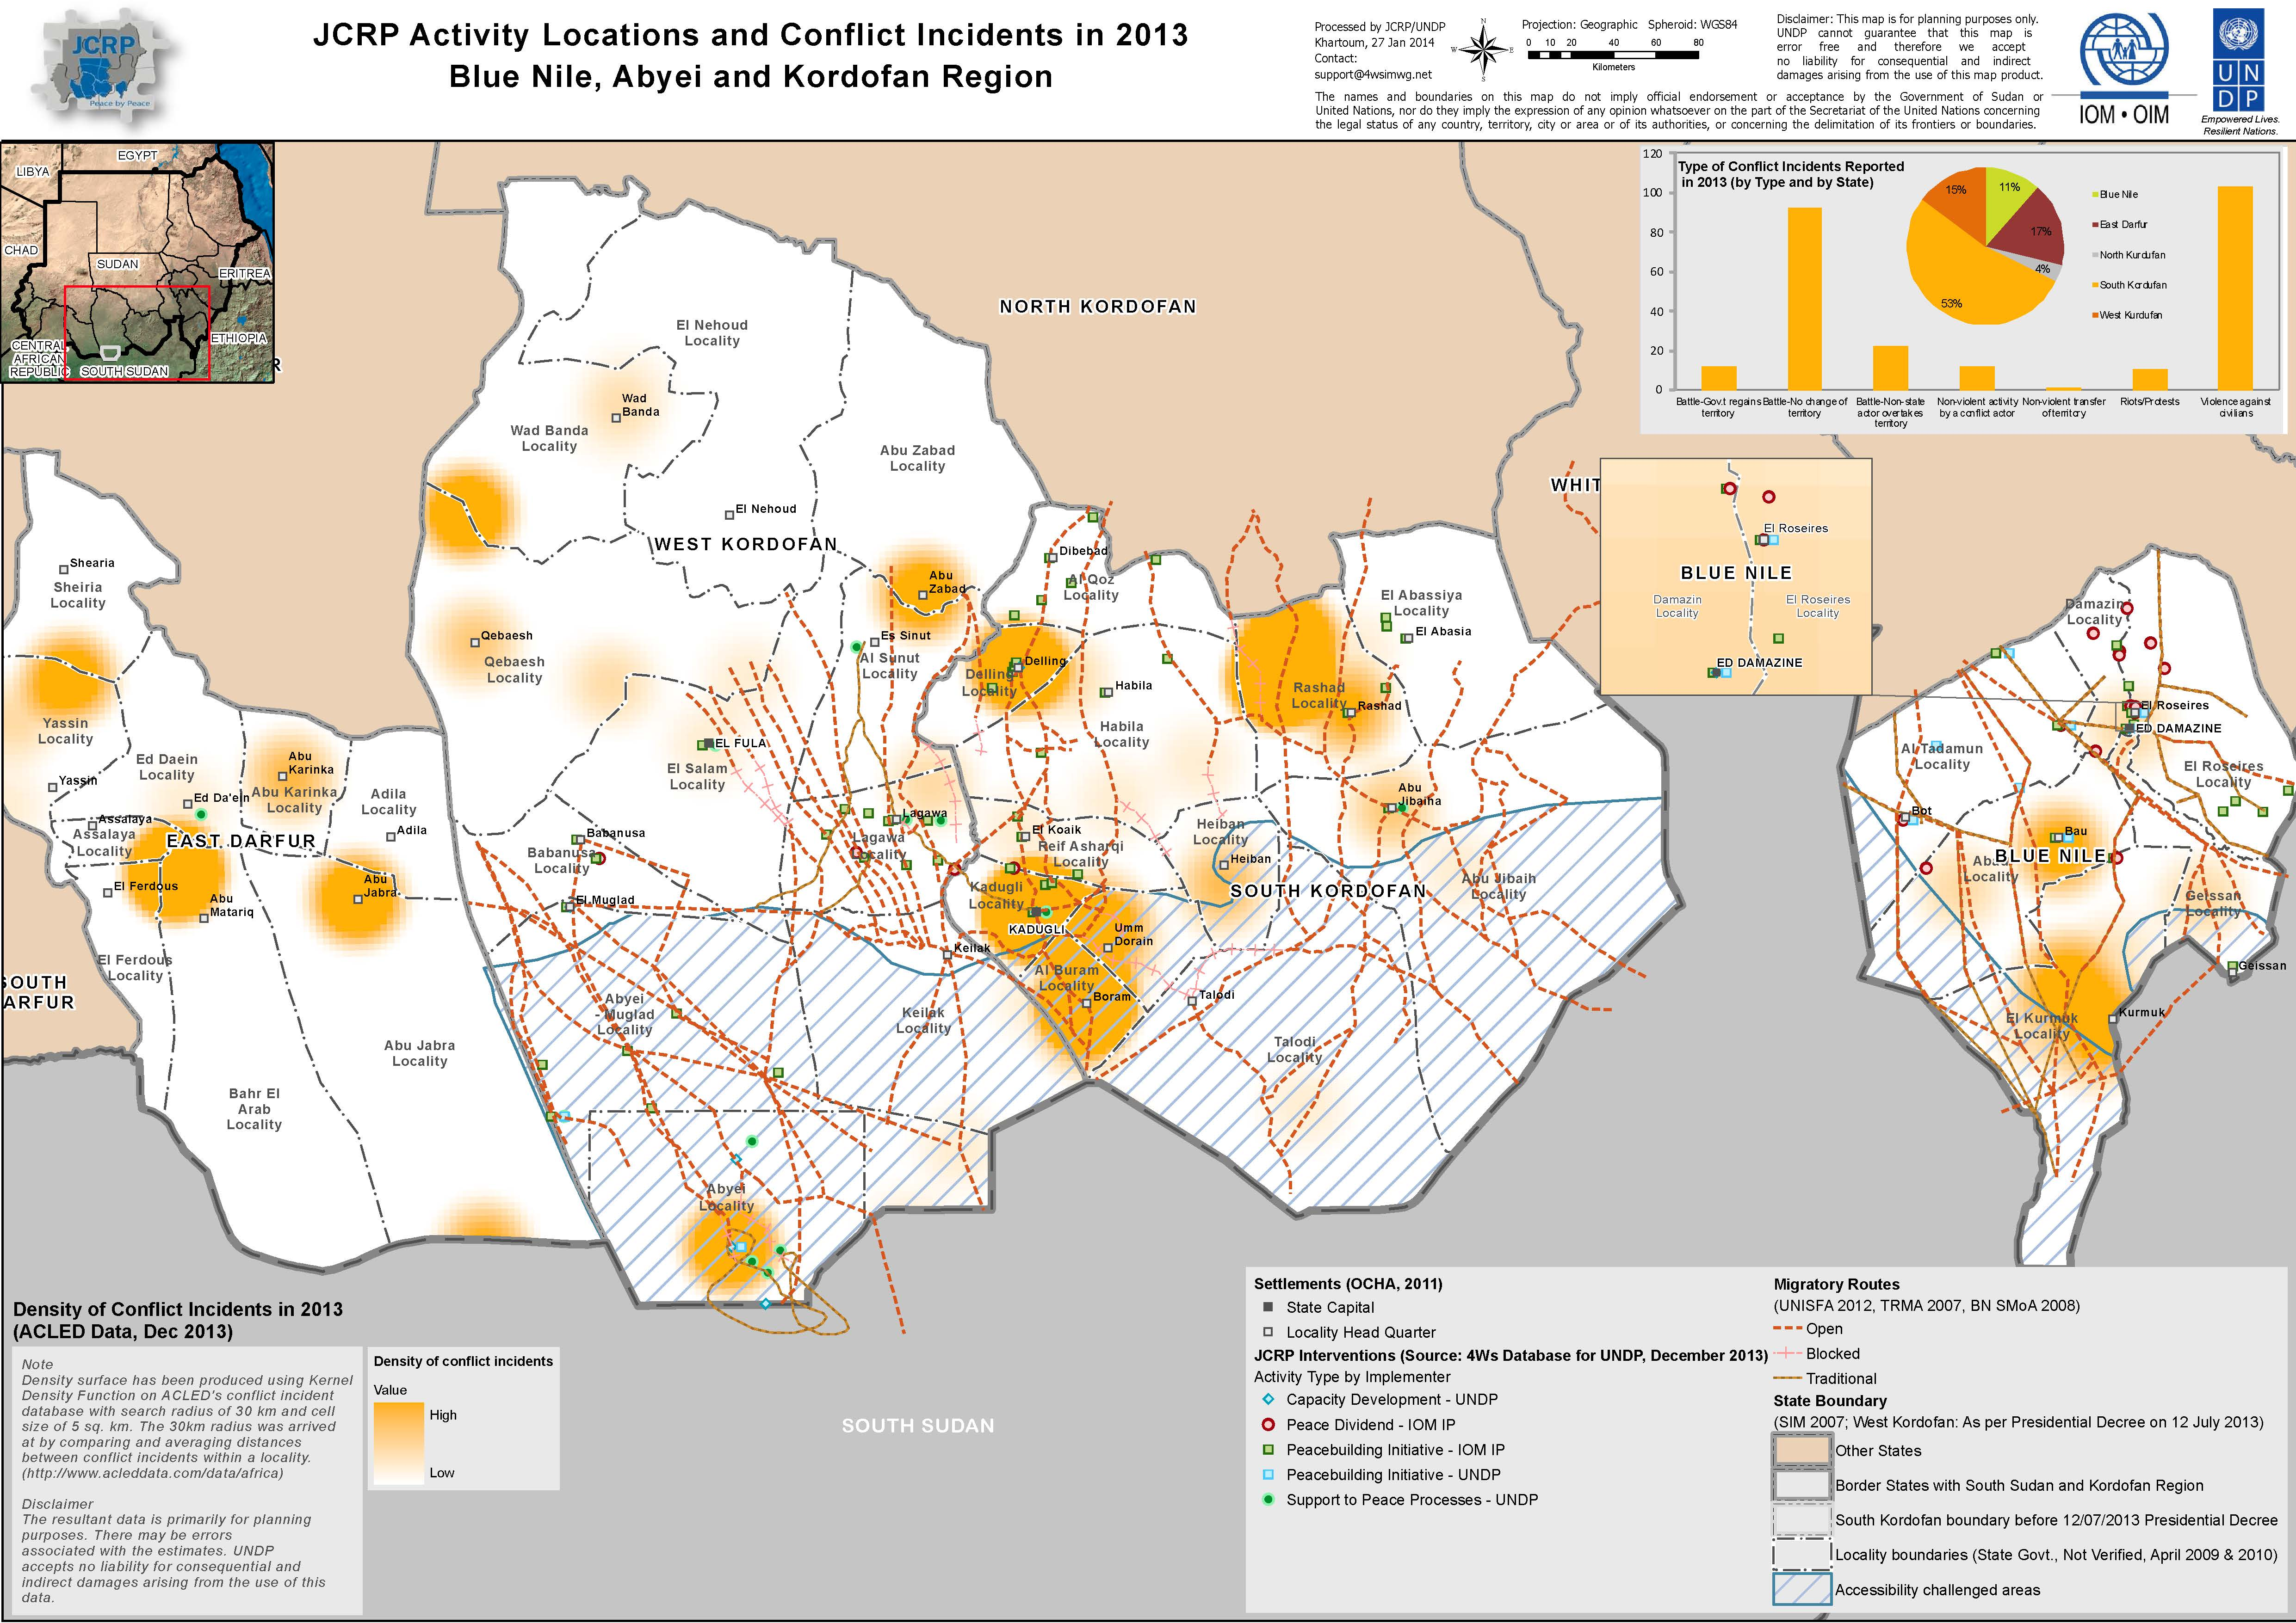

VII. Partnerships and Sustainability

Partnership with a growing range of stakeholders including Government, Civil Society, Academic and International Peacebuilding organizations lies at the heart of JCRP’s overall strategy and approach. The development of linkages between organizations working in peacebuilding and developing the capacity of peace actors is also essential to ensuring the sustainability of the benefits of JCRP’s work beyond the life of the programme.

The main partners of the JCRP are state Government mechanisms mandated to work on peacebuilding (such as the RPCM and the Peace Council) and a variety of local civil society actors engaged in peace activities in South Kordofan, Blue Nile and the Abyei Area.

With a view to promoting greater consistency and coherence within the peacebuilding and conflict resolution agendas, and effectively bringing community level demands into the broader peace domain, JCRP also engages informally with a broad spectrum of actors, including:

UNDP’s Community Security and Arms Control programme works in the same areas as the JCRP, with some overlapping goals. Close coordination of project activities is essential to avoid duplication.

Relevant UN agencies - to explore partnership and coordination and ensure inter-agency synergies and complementarities.

Relevant State Government institutions, such as Line Ministries. Such bodies often have direct responsibility over the areas of work of some JCRP grantees and have also benefitted from technical support in conflict sensitivity.

Federal Ministries provide inputs and guidance to the project strategy as well as advice on linkages on peacebuilding work between different states in Sudan. The Ministry of Finance and National Economy will coordinate these inputs, drawing support and inputs particularly from the Higher Council for Decentralized Governance.

Civil Society Organizations and Community level peacebuilding mechanisms also play a vital role in conflict resolution and peacebuilding efforts.

Academic Institutions that specialize in peacebuilding can also play an important role in the peacebuilding process. In recognition of this, UNDP signed a Letter of Agreement with the University of Khartoum’s Peace Research Institute in late 2013, with plans for expanding this partnership and developing linkages to regional and international institutions afoot for 2014.

Developing and working through partners has also been essential to the achievements of Outputs 3 and 4. IOM has developed constructive partnerships that have proven critical to effective programme implementation.

The key partnerships developed during the reporting period were with fourteen CSOs funded to carry out a range of peacebuilding activities in their communities, such as supporting reconciliation processes between conflicting tribal groups or provided vocational training skills to youth and women, among others.

IOM also collaborated closely with the PC and the RPCM, who played a key role in ensuring the smooth implementation of JCRP Output 3 and 4 activities. They assisted CSOs and company partners in acquiring the necessary permissions and facilitated introductions to beneficiary groups and other local authorities. They also stepped in to clarify concerns or resolve disagreements among partners when needed.

Partnerships were also established with BNS Ministry of Education, BNS Ministry of Agriculture, and WES in both BNS and SKS. These partnerships were critical to building community level understanding of the activities and to ensure buy-in from beneficiaries and key stakeholders – a necessary prerequisite for generating the desired impacts of targeted peace dividends.
The partnership with the BNS Ministry of Agriculture (MoA), together with PC was essential for the demarcation and compensation of cattle migration corridor. Once the Farmers and Pastoralists Conference was concluded, the PC facilitated dialogues with farmers and pastoralists in order to reach clear agreement regarding the delineation of the corridors. The BNS MoA also played a key role in determining the land that would be impacted and the level of compensation that would be required for each farmer giving up land in favor of the corridor.

The BNS Ministry of Education (MoE) also supported the school construction process by allocating land for the school and through providing designs for the furniture.

All the partnerships mentioned above not only assisted the programme implementation process, but also enhanced the likelihood that programme benefits to communities will be sustained beyond the life of the programme. This is because of the central role partners played throughout the process, thereby increasing the ownership and buy-in on the part of a wide range of Government and community stakeholders.

VIII. Financial Summary

Overview of financial resources for 2013

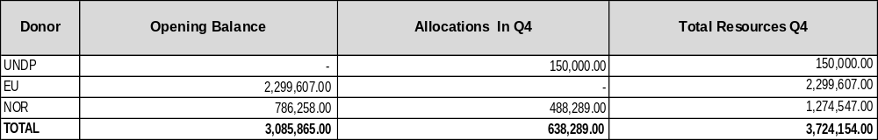

Overview of budget and expenses per output

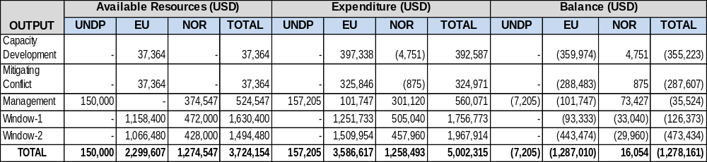

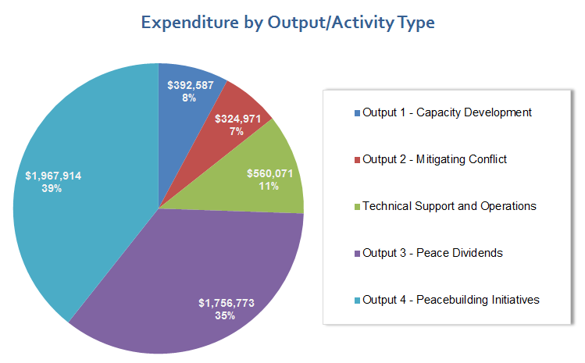

Note:

Data contained in this report is an extract from UNDP financial records. All financial information provided above is provisional and the certified financial statements will be provided in July 2014.
Annex 1: Progress Review: detailed matrix of activities and results

Output 1 | Indicators | Baseline | Annual target | Progress against target
Effective and sustainable institutions are in place in support of community-level conflict resolution and prevention.  Budget: 237,564 USD  Expenditure to date: 425,703 USD | New members of RPCM, PC and Native Administration trained in Conflict Mediation and Do No Harm. | In 2012 the RPCM and PC were trained in conflict sensitivity, peacebuilding and mediation. | All new members of the RPCM, PC and Native Administration trained on Conflict Mediation and Do No Harm. | One Conflict Transformation & Peacebuilding Training was conducted with the Blue Nile Peace Council on Sept 9-12. Trainings for the newly formed Peaceful Coexistence and Social Peace Committee (formerly RPCM) is planned for the first half of 2014.
 | # of functioning conflict resolution mechanisms (Government and Civil Society (at all levels). | RPCM in SKS  PC in BNS in 2012 | UNDP staff seconded to the RPCM and PC to collect official documents produced by new State authorities. | Peace Council still in place. RPCM dissolved and replaced with Peaceful Coexistence and Social Peace Committee, which was established in November 19, 2013
 | % of community members indicating effectiveness of the RPCM and PC | This indicator was not monitored in 2012 | Focus group discussions commissioned to a Sudanese academic institution/ Small scale survey using structured questionnaire. | 73% of community members surveyed at a community consultation in Delling, SKS responded that the RPCM were to some extent or very much effective in contributing to conflict resolution in their community. Surveys were not able to be carried out in other parts of SKS due to security/access constraints.
 | % of Community level Peace actors trained by JCRP that report using skills and tools gained through JCRP supported trainings in the 3 months following completion of training. | Baseline Not Available | 70% of community level peace actors trained by JCRP report using skills and tools gained through JCRP supported trainings in the 3 months following completion of training. | A follow up survey, designed for use three months after each training was developed and will be used for all trainings as of Q4, 2013. The results of these surveys will become available as of Q1, 2014.

Activity Result 1.1 | Indicators | Baseline | Annual Target | Progress against Target
Activity Result 1: RPCM and PC capacitated to design and lead the implementation of peacebuilding activities with limited guidance from JCRP staff. | Managerial and technical capacity of RPCM and PC. | Capacity Assessments carried out for RPCM and PC in 2012 | RPCM and PC demonstrate increased managerial and technical capacities by delegating responsibilities to increase delivery | The PC is increasingly taking on more managerial and technical responsibilities with regards to the design, planning, implementation and monitoring of activities. They are also increasingly playing a role in coordinating communications between key stakeholders on the ground. A second organizational capacity assessment is planned for early 2014 to assist planning for further capacity development in Phase II. An initial organizational capacity assessment is also planned for the newly formed Peaceful Coexistence and Social Peace Committee in the first half of 2014.
Planned activities |  | Results
1.1.1 One training on peace building and conflict transformation, including conflict sensitivity and do no harm delivered jointly to new members of RPCM and Peace Council.  1.1.2 One advanced training on mediation, negotiation and facilitation skills delivered jointly to all members of RPCM and PC.  1.1.3 On job training on organizational development including project management, monitoring & evaluation, reporting and financial management delivered to key members of RPCM and PC.  1.1.4 One training on reporting techniques and analytical skills to support data management and production of conflict analysis delivered jointly to key new members of RPCM and key members of PC.  1.1.5 Workshop to share best practices from PC and RPCM.  1.1.6 Update standardized training manual on peace building and conflict transformation with modules on conflict sensitivity and DNH Principles, and tailored to the context of the Three Areas.  1.1.7 Develop a standardized training manual on project management, fund management and reporting skills tailored to RPCM and PC.  1.1.8 Support to RPCM and PC in development of organizational manuals.  1.1.9 Secondment of up to five national staff to government mechanisms in SKS, BNS and Abyei Area (when possible).  1.1.10 Support to South and West Kordofan State authorities with establishment/restructuring of State peace building structures |  | 1.1.1 One Conflict Transformation & Peacebuilding Training with PC/stakeholder (Total 27, M/23, F/4) in Sept in Damazine.  1.1.2 This activity did not take place as planned due to the dissolution of the RPCM prior to it taking place. It is now planned to take place, but separately, in 2014.  1.1.3 The 3 members of the BNS Team were collocated with the PC at the up until November, 2013. This allowed for close collaboration with the PC members in the development of concept notes, planning and implementation of activities, along with the transfer of knowledge and skills in project management, administration and financial management. The Blue Nile Team also facilitated stronger linkages with implementing partners and as a result the PC is now taking more of a lead role in many activities. Although the Blue Nile Team is no longer co-located with the PC, this close collaboration continues.  1.1.4 Whilst a formal training did not take place, the Blue Nile Team provided on-the- job training in data management and reporting, which has resulted in higher quality inputs from the PC. This work will continue into 2014 with the PC taking greater responsibility for reporting as their capacity increases.  1.1.5 A team Self Review workshop was conducted with 15 members of the PC on Nov 20. Best practices were explored, key impacts identified and lessons learnt captured.  1.1.6 Existing training materials have been compiled and a review conducted. Areas for improvement have been identified. A revised standardized training manual to be completed early in Phase II.  1.1.7 A decision was taken that this should be outsourced to an external consultant. This is due for completion by the end of the current project phase.  1.1.8 A decision was taken that this should be outsourced to an external consultant. This is due for completion by the end of the current project phase.  1.1.9 The Blue Nile team was operating in Damazine throughout the reporting period, supporting the Peace Council. Due to security concerns in SKS, staff with technical expertise were based in Khartoum, with frequent missions to the field. One international peacebuilding expert was relocated to Abyei.  1.1.10 In SKS the RPCM was dissolve with a new mechanism, the Peaceful Coexistence and Social Peace Committee (PCSPC), established on Nov 19, 2013. A new state peacebuilding structure has not yet been formed in the newly re-created WKS.

Activity Result 1.2 | Indicators | Baseline | Annual Target | Progress against Target
Community-level peace builders trained to design and implement peacebuilding activities | Demonstrated applied skills of trained participants in planning, designing and implementation of peace activities | Baseline (2012): Community level peace builders assessed as requiring capacity building re; planning and implementation of peacebuilding activities | 50% of trained participants lead conflict resolution activities in their communities in the 3 months following completion of trainings | 68% - Follow-up surveys were introduced for trainings commencing in Q4. Of the 32 participants surveyed so far, 22 led conflict resolution activities in the 3 months following completion of training.
 | # of community level peace builders attending trainings (including youth and women) | Baseline (2012): 619 community level peace builders attended trainings (10%, 10% youth) | 350 Community level peace builders trained (50% women, 30% youth) | 729 Community level peace builders were trained (Women 21.1%, Youth 28%)
Planned activities |  | Results
1.2.1 Three basic trainings in conflict transformation, peace building and mediation skills for Native Administration leaders and Locality Commissioners in South and West Kordofan  1.2.2 Three basic trainings (one in South Kordofan, one in Blue Nile, one in Abyei) in conflict transformation, peace building and mediation skills targeting community-level women peace builders (and women’s groups).  1.2.3 One basic training in conflict transformation, peace building and mediation skills targeting parent-teacher associations working at the community level in South Kordofan.  1.2.4 One training in principles of dialogue and mediation for Native Administration leaders (not part of the Peace Council) in Blue Nile, S and WKS and two in Abyei.  1.2.5 One advanced training in principles of dialogue and mediation for community-level peace platforms (such as the Miriam Peace Committee) and political parties in South Kordofan.  1.2.6 One Training-of-Trainers for Peace Ambassadors in South Kordofan/West Kordofan and Blue Nile.  1.2.7 Support to Peace Ambassadors-led training to community-level peace builders in South & West Kordofan and Blue Nile.  1.2.8 Mapping, forming and training of peace committees along the migratory routes in Blue Nile. |  | 1.2.1 Three basic trainings took place with Native Administration - one in SKS on April 14-16 (Total 30. M23, F7), another in WKS on Dec 28-29 (Total45, M/45) and one in Abyei on Aug 28-29 (Total 40, M/40).  1.2.2 Four trainings for women were conducted, one in BNS in Nov (30), the second in SKS in Oct (F/29), the third in Abyei in Nov (F/35), the fourth in SKS in Dec (F/25) and the fifth in Abyei in in November (F/35). In addition, five trainings were conducted targeting community leaders and young people in Abyei.  - Abyei – March 6-7 (25 youth, M/21, F/4))  - Abyei – Nov 1-2(30 Community leaders, M/30)  - Abyei –March 3-4 (29 Misseriya youth, M/24, F5))  - Abyei – June 21 - CT and PB training for Abyei Youth Association (Total 50, M/45, F5)  - Abyei – Sept 3-4, PB Training for Abyei Youth Association (Total 101, M98, F 3)  1.2.3 This activity did not take place as planned due to security clearances that were still pending for other activities.  1.2.4 Two trainings were conducted, one in WKS Dec 22-25 (M/40), the other in Damazine Dec 28-31 (M/40). A further training for Native Administration is planned for SKS in Q1. 2014.  1.2.5 This was not delivered as it was decided it would be more effective for the members to participate in the Peacebuilding Training for Youth, planned for Q1 2014.  1.2.6 One Peace Ambassadors Training was conducted between Oct 30- Nov 2 for 30 participants from both WKS and SKS in Kadugli (M/13, F17). The other training scheduled to take place in BNS did not take place as planned.  1.2.7 Support to a peace ambassadors-led in training to community level peace builders is planned for SKS in Q1. In WKS and BNS further capacity building support is required prior to the peace ambassadors conducting their own trainings.  1.2.8 This activity was completed between May 4 and August 31, 2013 (Also links to 2.1.2).

Activity Result 1.3 | Indicators | Baseline | Annual Target | Progress Target
Dispute monitoring system tracking flashpoints and peace processes in place, including an updated analysis of trends since 2009 in South Kordofan, Blue Nile and Abyei. | Demonstrated use of dispute monitoring system to plan peacebuilding activities | N/A | RPCM and PC to replicate model established by JCRP | An excel spreadsheet was developed tracking the status of peace processes, with input from the RPCM and PC.
Planned activities |  | Results
1.3.1 Dispute monitoring system to track local conflict flashpoints and peace processes designed with inputs from RPCM and PC technical staff.  1.3.2 Data from disputes tracked by JCRP since 2009 inputted to the system.  1.3.3 Multi-stakeholder workshop to map local flashpoints of concern in South Kordofan, Blue Nile and Abyei Area organized and data inputted to the system.  1.3.4 Comprehensive analysis report on trends in local disputes and peace processes since 2009 produced by UNDP staff. |  | 1.3.1 An Excel spreadsheet has been developed tracking the status of peace processes with regular input from Government partners  1.3.2 An Excel spreadsheet has been developed tracking the status of peace processes with regular input from Government partners  1.3.3 The Multi-stakeholder workshops did not take place as planned due to the political sensitivity of the activity and a lack of buy-in from Government partners. However, one training focused on the development of Conflict Early Warning Systems was conducted on Dec 16 in Abyei for 99 members (M/70, F29) of the newly formed Abyei peace committees.  1.3.4 A comprehensive Conflict Analysis of the Three Areas was completed in November 2013.

Activity Result 1.4 | Indicators | Baseline | Annual Target | Progress Target
Government and civil society organizations that are not directly working on peacebuilding understand principles of conflict sensitivity and Do No Harm. | Extent to which UN agencies, line ministries and CSO’s understand and apply the principles of conflict sensitivity. | N/A | UNISFA plans to engage Misseriya and Ngok Dinka communities and Integration of conflict sensitivity principles. | Following the conflict sensitivity training with UNISFA staff in Feb, UNISFA revised their buffer zone strategy, engaging both Misseriya and Ngok Dinka communities in the establishment of the buffer zone.
Planned activities |  | Results
1.4.1 Two advanced trainings on conflict sensitivity and Do No Harm principles to UN agencies operating in the Abyei Area and UNISFA and MoA SKS.  1.4.2 Three trainings (two in South Kordofan, one in Blue Nile) to Line Ministries on conflict sensitivity and Do No Harm principles.  1.4.3 One JCRP Orientation to NIS and Military Intelligence in Blue Nile. |  | 1.4.1 Three trainings were conducted;  - Training of 17 staff (M12/F5) from NGOs/CBOs in CS and DNH Abyei in Feb  - CS and DNH training to 49 (M45/F4) staff of UNISFA in Abyei in Feb  - Conflict Sensitive Planning Training for 40 UNISFA staff (M35/F5) in Sept  1.4.2 One Training on CS and DNH was conducted for the SKS Ministry of Agriculture and Natural Resources in April (Total 30, M25/F6). A further training is planned with Line Ministries in BNS for Q1 2014.  1.4.3 This activity was put on hold at the request of NIS and MI.

Output 2 | Indicators | Baseline | Annual target | Progress against target
Immediate and emergent flashpoint conflicts mitigated through inclusive peace processes  Budget: 224,842 USD  Expenditure to Date: 514,537 USD | 1) % of JCRP supported peace processes continuing to hold six months after their conclusion. | 16/16 or 100% in 2012 | 80% | 17/18 Peace Processes continued to hold in 2013
 | 2) % of peace process participants representing vulnerable groups (women, youth). | 2013: 20% | 50% | A total of 2236 people participated in JRCP peace process activities (conferences and workshop). Of these 1684 or 75% were male and 552 or 25% were female. The number of youth participating was not recorded
 | 3) Degree of resilience to state-wide conflict as a result of peace processes. | Not available | 80% peace process participants report they are less likely to join statewide conflict | Given the political sensitivities referred to in Section V., this indicator was not monitored.

Activity Result 2.1 | Indicators | Baseline | Annual Target | Progress against Target
Selected peace activities designed, supported and implemented in partnership with government counterparts in response to flashpoint conflicts in Three Areas | Number of peace processes designed and implemented in partnership with Government counterparts | Eight in 2012 | 12 new peace processes in 2013 | Four new peace processes were designed and implemented in 2013
Planned activities |  | Results
2.1.1 Dialogue to facilitate safe access to Ethiopian pasture for pastoralists from Blue Nile.  2.1.2 Consultations/Dialogues along migratory corridors in Blue Nile.  2.1.3Peace festival organized in Damazine and Abyei to engage youth in peace activities.  2.1.4 Lagawa Community Dialogue (Western Nuba – Misseriya Zurug) designed and implemented.  2.1.5 Saror-Heiban and Daju-Eininat, Diree-Toroj peace conferences and follow up activities to implement agreement.  2.1.6 Follow up activities to implement recommendations of Misseriya land conference, Abujunuk – Umsalim.  2.1.7 Misseriya – Rizegat reconciliation process designed and implemented.  2.1.8 Monitoring of previous peace processes now in conflict area: Darneala-Gulfan, Katla-Wali, Shatt-Rawawga, Kawahla-Tagli, Harazaya Nuba – Harazaya Misseriya, Hadara – Hawazma.  2.1.9 Six Intra-community dialogues for Dinka (3) and Misseriya (3) in the Abyei Area.  2.1.10 Dinka-Misseriya inter-community dialogue in the Abyei Area.  2.1.11 Up to 4 additional peace activities designed and implemented on flashpoints emerging throughout the year. |  | 2.1.1 This activity did not take place as planned as further dialogue between Ethiopia and Sudan is required at a national level, prior to further action.  2.1.2 Twenty Seven dialogues were conducted in 27 settlements between May 5 and Aug 31  2.1.3 A Universal Peace Day was conducted in Damazine on Sept 21. It was attended by approximately 7500 people (Approx. M/5500, F/2000).  2.1.4 A Lagawa community dialogue and follow up Reconciliation Conference took place in Lagawa in late 2012. In 2013, this was followed up with a Peace Dividends Workshop conducted in Lagawa on May 8-10 to identify the peace dividend priorities for implementation by IOM. (Total Participants: 30, M/22, F/8).  2.1.5 Threes activities were conducted;  1. The Saror-Heiban Conference took place on Feb 22 – March 1(10 day Conference) in Ed Daein, East Darfur for Saror-Heiban (Total Participants: 300, M/240, F/60).  2. A conference for the Daju-Eneinat took place in November 2012, Lagawa. Following the November Reconciliation Conference, a Peace Dividends Workshop was conducted in Lagawa on May 8-10 to identify the peace dividend priorities. (Total Participants: 30, M/27, F/6)  3. A conference for the Diree-Toroj was conducted by Government. JCRP provided technical support to the RPCM who facilitated the conference.  The conference took place in Feb 2013 in Lagawa Locality, Mango Settlement. It was attended by The community leaders, Native  Administration, RPCM, Lagawa Commissioner The key conference  outcomes were;  - The signing of a Reconciliation Agreement between Diree and Toroj  - Hostilities ceased  - The participants committed themselves to be tolerant and to live peacefully  Members from both tribes are now living in Mango, sharing markets and resources.( Total Participants: 270, M/200, F/70)  2.1.6 A follow up workshop for the Daju-Eneinat took place in Lagawa in May. It was attended by 30 people (M22/F8)  2.1.7 A reconciliation conference, attended by 270 people (M/200, F/70), was conducted by the SKS Government, with support of JCRP. On June 1, 2013 a Reconciliation Agreement signed. The key outcomes of this conference were;  - Compensation was paid by Misseriya to Rizegat and vice versa  - Misseryia accepted to share cattle corridors with Rizegat  - Misseriya welcomed Rizegat to their area  2.1.8 All these localities are in SPLM controlled areas. No access was possible throughout 2013.  2.1.9 Three Intra-community dialogues were conducted in the Abyei area.  - 358 Misseriya people (M197/F161) participated in a 2 day intra-community dialogue in Mekines, Abyei area in March  - 80 Dinka people (M51/F29) participated in a 1-day intra-community dialogue in Majak, Abyei area in June  - 85 Dinka people (M60/F25) participated in a 1 day intra-community dialogue in Leu, Abyei area in June  - 133 Dinka people (M65/F68) participated in a 1 day intra-community dialogue in Abathok, Abyei area in June  2.1.10 The Dinka-Misseriya inter-community dialogues did proceed as planned due to escalation and protraction of tensions between communities following the killing of the Dinka chief on May 4, 2013.  2.1.11 A Peaceful Coexistence Conference took place in AbuJibaih Dec 22-24, 2013. It was attended by 152 people (M140/F12). As a result of the conference, an agreement was reached between the Kaw, Njaro, Fungur and Asakot, Kenana and Awlad Hemain tribes in the AbuJibaih area committed to cease hostilities, with the local Government also committing to provision of basic services, including local policing.

Activity Result 2.2 | Indicators | Baseline | Annual Target | Progress against Target
Selected peace activities designed, supported and implemented in partnership with civil society in response to flashpoint conflicts in Three Areas | Number of peace activities designed and implemented in partnership with civil society organizations. | 5 in 2012 | 16 | Six selected peace activities were carried out under Activity Result 2.2
Planned activities |  | Results
2.2.1 Peace Ambassadors implement 4 community level peace initiatives with technical guidance and logistical support from JCRP.  2.2.2 Locality Commissioners and Native Administration implement 4 community level peace initiatives with technical guidance and logistical support from JCRP.  2.2.3 Meiram Peace Committee implements two community level peace initiatives with technical guidance and logistical support from JCRP.  2.2.4 The Goodwill Committee on Misseriya Reconciliation implements two community level peace initiatives with technical guidance and logistical support from JCRP.  2.2.5 Up to 3 additional community level peace activities organized by civil society actors.  2.2.6 Organize sports for peace activities in Abyei Area and Blue Nile targeting youth. |  | 2.2.1 JCRP will be supporting Peace-Ambassador-led training to community level peace builders in SKS in Q1, 2014.  2.2.2 This did not happen as planned. There were 3-4 changes of Commissioners during 2013 – so this made it difficult for this to take place.  2.2.3 The Meiram Peace Committee implemented two activities, with support of JCRP. These were;  - A Youth Forum on March 7-8 in Mairam (attended by 100 youth)  - The Misseriya–Rizegat Follow Up Forums in Sept 2013 in Al Mugadam, Um Elbashar, Abubateikh, Altibon, Umeraigat, Nour and Kardadi. This culminated in a one day conference in Nour with 200 people. The key Outcomes of the conference were;  - Misseryia confirmed commitment to payment of diya to Rizegat for the violations  - Misseriya confirmed readiness to establish joint follow up committees with Rizegat  - Misseriya opened all closed markets to Rizegat tribe  The Misseriya confirmed commitment to Babnosa Agreement and readiness to accept Rezaigat in the area  2.2.4 Follow Up Dialogues of Misseriya Clans Reconciliation Agreement (between Saror-Heiban tribes) was implemented by Goodwill Committee on Misseriya Reconciliation, with support from JCRP in 3 settlements in Al Salam Locality, WKS on Dec 27-31. In total, 495 people (M393/, F/102 participated in the dialogues. The outcomes of these dialogues were;  - A Government commitment to payment of Diya  - Awlad Heiban tribespeople moved to a new location  - Youth from both sides committed to the reconciliation accords  - Commitment from the rest of the Awlad Saror tribe to re-locate  2.2.5 No additional community level peace activities by CSOs were carried out as CSOs put forward their initiatives via the Call for Proposals.  2.2.6 In Abyei, Sports equipment was provided to the Abyei Youth Association. The establishment of teams, regular practice sessions and the planning of tournaments are all planned for Q1 2014. Further Sports for Peace activities are also planned for BNS in Q1 2014.

Activity Result 2.3 | Indicators | Baseline | Annual Target | Progress Target
Post-conflict community-based priorities identified and action plans developed in SKS, BNS and Abyei. | Number of priorities identified through local-level peace processes addressed through grants | 12% in 2012 | 16/66  addressed through grants in relation to 4 peace processes (BNS 1, SKS 3) | 24% of priorities identified through local-peace processes addressed through grants
Planned activities |  | Results
2.3.1 Participatory assessment of water points along migratory routes in Blue Nile State  2.3.2 Participatory assessment of corridor demarcation needs (confirmation of Government identified needs with community members).  2.3.3 Abujunuk – UmSalim, Diree-Eneinet and Daju-Eneinat peace dividend workshops).  2.3.4 Up to 4 additional peace dividend workshops, depending on progress in peace processes. |  | 2.3.1 The participatory assessment of water points was conducted in May, 2013.  2.3.2 Dialogues took place in 27 settlements between May 5 and Aug 31 (also reported under 2.1.2)  2.3.3 Two activities were completed;  - A follow up workshop was conducted with the Daju-Eininat community representatives to identify peace dividend priorities was conducted in May in Lagawa Locality, SKS. It was attended by 30 people (M/22, F/8)  - The Abujunuk-Umsaleem Peace Dividends Workshop took place Dec 29-30 in Al Sunut Locality, WKS. It was attended by 33 people (M/27, F6)  No Peace Dividend workshop took place for Diree-Eininat – Diree, Daju and Eininat live in the same area, so the needs of the Diree people were also taken into account in the Peace Dividends workshop of Dajo-Eneinat that took place in Lagawa on May 8-10. This meant that a separate workshop was no longer needed.  2.3.4 No additional peace dividend workshops were carried out during 2013.

Output 3 | Indicators | Baseline | Annual target | Progress against target
Targeted peace dividends delivered to communities in accordance to priorities identified during local peace processes  Budget: $1,158,400 USD  Expenditure to Date: $501,045 USD | # of individuals directly benefiting from peace dividend delivery | N/A | 67,000 people benefiting from peace dividends interventions | 26,400 beneficiaries (5,280 males, 8,426 females, and 12,694 children)
 | % of beneficiaries reporting that peace dividend delivery has made it more likely they will remain at peace | N/A | 80% of beneficiaries report that peace dividend delivery has made it more likely they remain at peace. | Interviews conducted in BNS regarding the cattle migration corridor highlighted the positive impact this dividend was already yielding. The PC also advised that incident reports to police have dropped from around 400-500 each previous harvest season to less than 30 in the current harvest season, as of November.

Activity Result 3.1 | Indicators | Baseline | Annual Target | Progress Target
Grants disbursed to successful bidders to implement identified interventions in SKS | No. of peace processes addressed through grants. | N/A | 5 peace processes addressed through grants (4 in SKS and 1 in BNS) | 4 peace processes (3 in SKS and 1 in BNS) addressed
Planned activities |  | Results
3.1.1 Conduct assessment of 3 water points and corridor demarcations/compensation in Blue Nile State.  3.1.2 Conduct assessment of planned construction/ rehabilitation works to establish the required technical specifications for next phase and for 2 schools in BNS and three water-yards in SKS.  3.1.3 Open tenders for each intervention based on the technical specifications inviting commercial companies to submit their bids.  3.1.4 Sign service contracts with the successful bidders to deliver peace dividends for 4 peace processes. |  | 3.1.1. All assessment missions were completed for the 3 water points and corridor demarcations/compensation in Blue Nile State in addition to other activities mentioned above in order to create tender documents.  3.1.2. Assessment was conducted and necessary tender documents were prepared for 2 schools in BNS and 3 water yards in SKS.  3.1.3 Tenders were opened according to IOM procurement regulations and in coordination with respective grants committees.  3.1.4. Contracts were approved by respective grants committees and duly signed by winning contractors to deliver peace dividends that resulted from 4 peace processes

Activity Result 3.2 | Indicators | Baseline | Annual Target | Progress against Target
Grants disbursed follow Conflict Sensitivity and Do No Harm Principles. | Grants disbursed follow Conflict Sensitivity and Do No Harm principles. | N/A | 100% following of the principles | All activities were identified and agreed upon through peace processes, securing the necessary buy-in from communities. Conflict sensitive principles are thoroughly complied with throughout the implementation. For corridor demarcation, fixation of stones strictly followed the agreements made in line with the MoA. Where clarification was needed, the contractor was able to refer to the PC, UNDP and IOM.
Planned activities |  | Results
3.2.1 Carry out regular technical Monitoring & Evaluation visits of ongoing construction/rehabilitation works.  3.2.2 Carry out impact assessment at each implementation site six months after the delivery of peace dividends to measure changes in behavior and perception of conflict through participatory approach. |  | 3.2.1. For BNS, monitoring visits were conducted directly by IOM engineers each month from Aug-Dec. In between these monitoring missions, government counterparts, contractors, and UNDP staff on the ground worked closely together to monitor implementation and manage emerging operational issues.  3.2.2. As Blue Nile State interventions were completed in Q4 of 2013, formal six month assessments will take place in 2014.

Output 4 | Indicators | Baseline | Annual target | Progress against target
Initiatives delivered in support of stability, reconciliation and peaceful coexistence  Budget: $1,o66,480 USD  Expenditure to Date: $514,537 USD | # of individuals directly benefiting from catalytic peace building initiatives | Projected # of beneficiaries for First Call proposals in 2012 = 2,147 Direct, 27,000 Indirect (to be implemented in 2013) | N/A | Total 19,546 people (11,306 males and 8,240 females) benefited from 19 peacebuilding projects implemented in SKS and BNS.
 | Degree of resilience to state-wide conflict as a result of catalytic peace building initiatives | Not available | 80% of peace process participants report they are less likely to join state-wide fighting after the peace process | The indicator was not monitored due to the political sensitivity of the indicator itself. However, reports, monitoring missions and interviews with key informants indicate that significant contributions were made to conflict reduction in the JCRP target areas.

Activity Result 4.1 | Indicators | Baseline | Annual Target | Progress against Target
Implementing partners identified to address prioritized post-conflict community interventions in SKS and BNS | Number of Implementing partners identified | 35 local and international organizations | Relationship with 35 CSOs maintained; 10 more engaged | 53 CSOs in 2013
Planned activities |  | Results
4.1.1 Expand network of potential implementing partners through Call for Proposals and research, document contact details in a central roster.  4.1.2 Continue dialogue with known peace building actors to avoid duplication of work.  4.1.3 Drawing upon lessons learned from the first call for proposals; liaise with UNDP, Government Counterparts and donors to agree on priority interventions for implementation. |  | 4.1.1 As more stakeholders learned about the impact of JCRP activities during 2012, the network of potential implementing partners increased from 35 organizations at the end of 2102 to 53 organizations by the end of 2013.  4.1.2 A wide range of Government and community level peace building actors were engaged in the process of planning and carrying out project activities. Government counterparts also sat on grant committees to ensure harmonization with other activities being carried out and to avoid duplication.  4.1.3 An Evaluation conducted by the EU, internal reflections, feedback from government counterparts and implementing partners highlighted a range of lessons learned and recommendations to inform the second call for proposals. See Section V. for further details on lessons learned.

Activity Result 4.2 | Indicators | Baseline | Annual Target | Progress against Target
Implementing partners are able to design and implement peace building projects in a conflict-sensitive, efficient and transparent manner | Evidence of implementing partners planning and implementing projects in conflict sensitive, efficient and transparent manner | Not available | Project plans and implementation demonstrate adherence with conflict sensitivity principles, efficiency and transparency | After information sessions, pre-selections, and further comments from IOM, selected partners all demonstrated sound understanding of conflict dynamics in the areas they targeted, coupled with suggestions of meaningful interventions.
Planned activities |  | Results
4.2.1 Conduct 1 capacity building workshop for implementing partners covering conflict sensitivity / Do No Harm Principles (UNDP) and project management (IOM).  4.2.2 Organize regular follow-up sessions with implementing partners on reporting requirements, lessons learned, best practices and challenges encountered. |  | 4.2.1 A training workshop on Conflict Sensitivity/Do No Harm and Project Management was conducted jointly by IOM and UNDP in late April, 2013, in Khartoum, attended by the 26 partners who had been pre-selected for further formulation of project concepts. Based on the information provided through the training workshop, these organizations refined their initial concept notes and submitted for final selection.  4.2.2 A follow-up session was conducted in late July, 2013, in Khartoum to cover the JCRP reporting requirements, M&E, payment processes and modalities, and best practices from the First Call for Proposals. The Session was attended by nine organizations selected to implement 10 projects in BNS and SKS/WKS, which later split into SKS and WKS. In early October, 2013, IOM staff members conducted further follow-up sessions with implementing partners in BNS and SKS/WKS to provide guidance and discuss operational issues.

Activity Result 4.3 | Indicators | Baseline | Annual Target | Progress against Target
Grants disbursed to partners to implement identified peace building projects in SKS and BNS. | % of partners satisfied with grants disbursement process | Not available | 75% of grantees satisfied with training and technical advice | 80% of the grantees rated the overall quality of IOM grants management as either “Very Good” or “Excellent". 83% of the grantees rated the quality of the technical advice on CS, DNH and PCM provided by IOM/UNDP as either “Very Good” or “Excellent", while 17% of the partners rated the JCRP technical assistance as “Fair”.
Planned activities |  | Results
4.3.1 Announce one call for proposals, review and submit received proposals to the Grants Committee for selection and sign up of 10 grants agreements with implementing partners. Announce one call for proposals for next phase. |  | 4.3.1. A Call for Proposals was announced, and the Grants Committee approved 10 project proposals submitted by nine organizations in accordance with the JCRP grant selection process and criteria. A further Call for Proposals, which will mark the third round, will be launched in February 2014.

Activity Result 4.4 | Indicators | Baseline | Annual Target | Progress against Target
Interventions are implemented according to agreed programming principles. | Grant disbursed follow conflict sensitivity and Do No Harm principles | N/A | 100% following of principles | Full compliance with conflict sensitivity and Do No Harm principles was ensured through a range of measures over the course of the grant cycles. Prior to the selection of projects, IOM and UNDP provided training workshops on the CS and DNH principles and supported the grant applicants to further refine their proposals based on the training. The grant selection process was then conducted with the involvement of the grants committees, which provided further inputs on the relevance and potential peace-building impact of proposals. From the reports submitted by the grantees and the M&E evaluation report finalized in December 2013, it is evident that all projects funded under Output 4 complied with conflict sensitivity and Do-no-harm principles.
Planned activities |  | Results
4.4.1 Carry out regular joint monitoring and evaluation visits |  | 4.4.1 Since the launch of the grant projects, frequent coordination meetings were held with the implementing partners at the state capital level (Damazine for BNS and Kadugli for SKS), while JCPR team members also participated in some of the partners’ activities in the field. IOM staff also conducted several monitoring visits and a consultant was hired to evaluate the impacts of project activities on conflict reduction.

Annex I: Assets Inventory - JCRP

Project Title: JCRP
Award Number: 00014862
Project Number: 00077111
Date of report: 1st Jan 2014
# | Country Code | Business Unit | Item Description | S/N | Qty | Location | Date Acquired | Value | Custodian | Remarks
LAPTOPS
1 | SUDAN | SDN10 | DELL | C8G0J01 | 1 | KRT |  |  | JCRP
2 | SUDAN | SDN10 | DELL | B6CNM4J | 1 | KRT |  |  | JCRP
3 | SUDAN | SDN10 | DELL | 26630383897 | 1 | DMZ |  |  | JCRP
4 | SUDAN | SDN10 | DELL | 20778854509 | 1 | KRT |  |  | JCRP
5 | SUDAN | SDN10 | DELL | 26632063513 | 1 | KRT |  |  | JCRP
6 | SUDAN | SDN10 | DELL | 20778154669 | 1 | KRT |  |  | JCRP
7 | SUDAN | SDN10 | DELL | 20779134445 | 1 | KRT |  |  | JCRP
8 | SUDAN | SDN10 | DELL | 26628608377 | 1 | KRT |  |  | JCRP
9 | SUDAN | SDN10 | DELL | 20778807853 | 1 | KRT |  |  | JCRP
10 | SUDAN | SDN10 | DELL | 26630430553 | 1 | KRT |  |  | JCRP
11 | SUDAN | SDN10 | DELL | 20779181101 | 1 | DMZ |  |  | JCRP
12 | SUDAN | SDN10 | DELL | 20778901165 | 1 | KRT |  |  | JCRP
13 | SUDAN | SDN10 | DELL | 26630477209 | 1 | KAD |  |  | JCRP
14 | SUDAN | SDN10 | DELL | 20778108013 | 1 | ABY |  |  | JCRP
15 | SUDAN | SDN10 | DELL | 20778061357 | 1 | KRT |  |  | JCRP
Printer
1 | SUDAN | SDN10 | HP 2055dn | CNCKD75480 | 1 | KRT |  |  | JCRP
2 | SUDAN | SDN10 | SHARP | 3E021114 | 1 | KRT |  |  | JCRP
3 | SUDAN | SDN10 | HP | CNCKD75827 | 1 | DMZ |  |  | JCRP
4 | SUDAN | SDN10 | HP |  | 1 | KRT |  |  | JCRP
Thuraya Handsets
1 | SUDAN | SDN10 |  | 35601300638130-8 | 1 |  |  |  | JCRP
1 | SUDAN | SDN10 |  |  | 1 | DMZ |  |  | JCRP
Office Desks
1 | SUDAN | SDN10 |  |  | 3 | DMZ |  |  | JCRP
2 | SUDAN | SDN10 |  |  | 10 | KRT |  |  | JCRP
Office Chairs
1 | SUDAN | SDN10 | Small Chairs |  | 22 | DMA-KRT |  |  | JCRP
2 | SUDAN | SDN10 | Visitor Chairs |  | 10 | DMA-KRT |  |  | JCRP
3 | SUDAN | SDN10 | Big Chairs |  | 12 | DMA-KRT |  |  | JCRP
Conference Table
1 | SUDAN | SDN10 |  |  | 1 | DMZ |  |  | JCRP
Water Dispenser
1 | SUDAN | SDN10 |  |  | 1 | DMZ |  |  | JCRP
2 | SUDAN | SDN10 |  |  | 1 | KRT |  |  | JCRP
Air Condition
1 | SUDAN | SDN10 | LG | 304 HASP01830 | 1 | DMZ |  |  | JCRP
2 | SUDAN | SDN10 | LG | 304HAYE 01874 | 1 | DMZ |  |  | JCRP
3 | SUDAN | SDN10 | LG | 304 HAMG00371 | 1 | DMZ |  |  | JCRP
Filling Cabinets
1 | SUDAN | SDN10 |  |  | 1 | KRT |  |  | JCRP
2 | SUDAN | SDN10 |  |  | 2 | DMZ |  |  | JCRP

Annex II: Conflict Analysis Paper – Shifting Patterns in Conflict and Peace Dynamics in the Three Areas: Challenges and Opportunities
See Attached.

This is the only case of an infrastructural works implemented under Output 4 (Window 2). The project was selected under the 1st call for proposals launched in 2012.
EU Staged Evaluation report of the Instrument for Stability (IFS) in Sudan, September 2013, pg.11.
Reference to RPCM in the work plan implies RPCM and any successor institutions that may come about as a result of the re-formulation of RPCM in South Kordofan State and establishment of a peace building body in West Kordofan State.

